**LAB ASSIGNMENT**

**Name: Deepankar Sharma**

**Student ID: 233512013**

**Course Code: OMC209 Last Date of Submission: 31/07/24**

**Course Title: Advanced Java Programming Laboratory Maximum Marks: 30**

Program 1:

Create a Java class “Employee” with the attributes - employee number, name, designation and salary.

1. Implement methods to set and display these attributes
2. Implement parameterized constructors for initializing these attributes.

Use “this” keyword to illustrate the difference between instance variable and constructor parameters. Display these attributes.

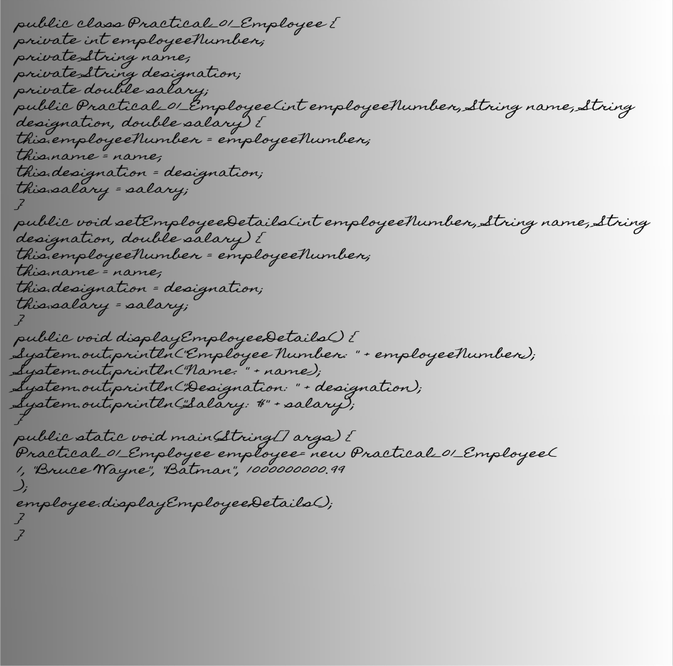

Output:

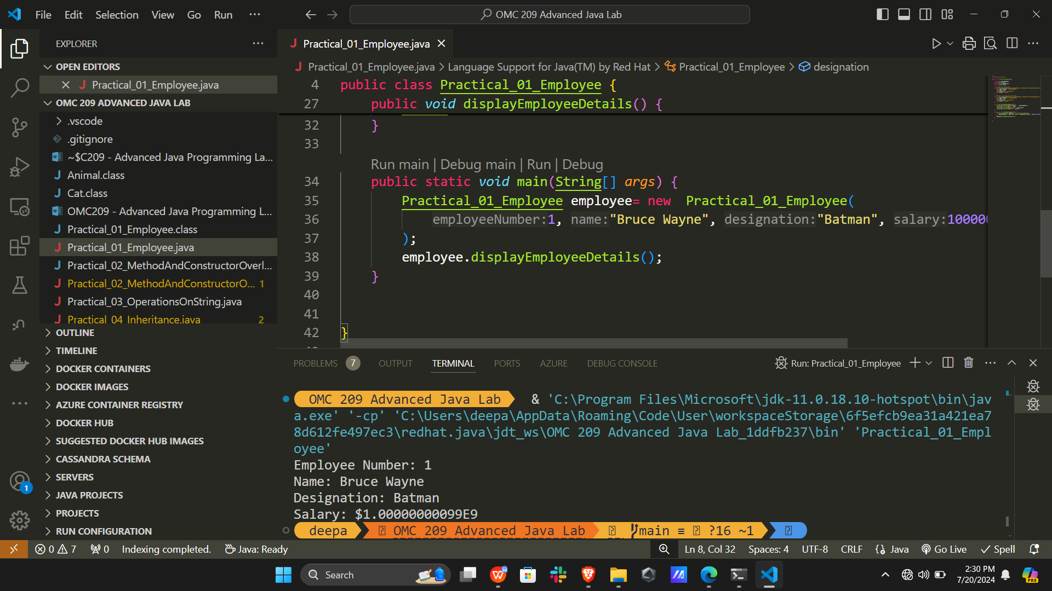

Program 2:

Write a Java program to demonstrate method overloading and constructor overloading.

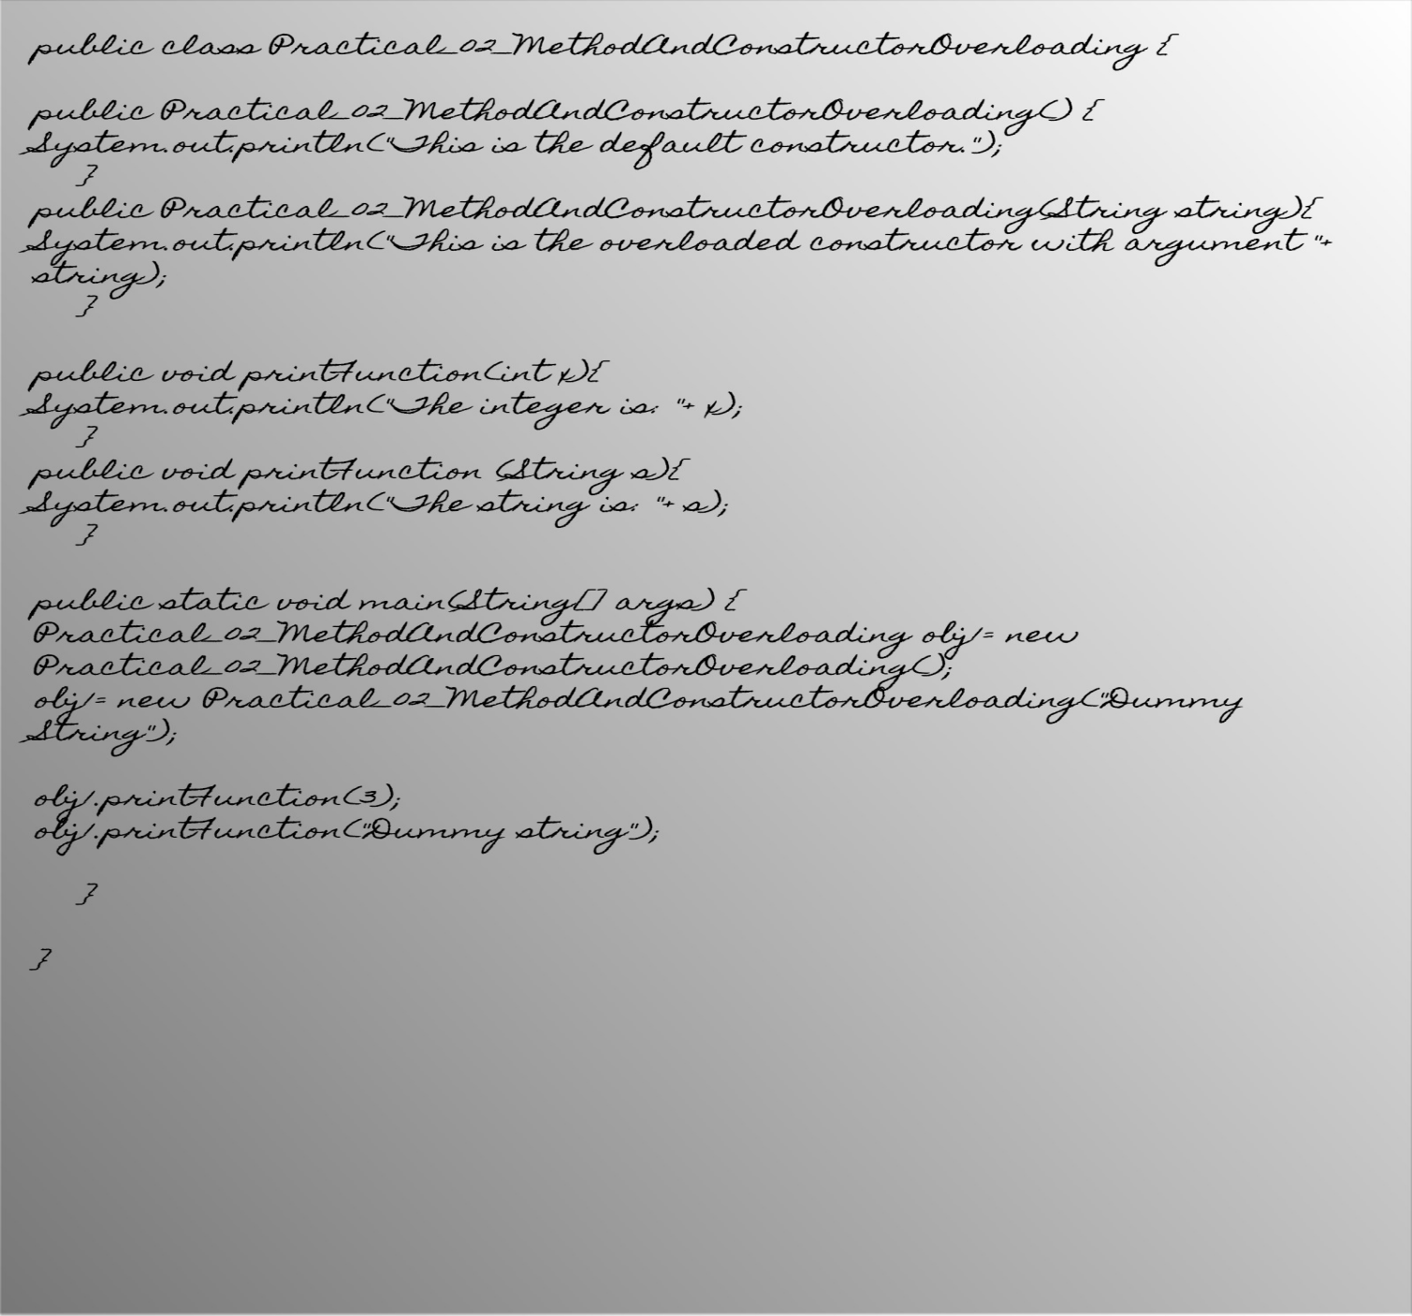

Output:

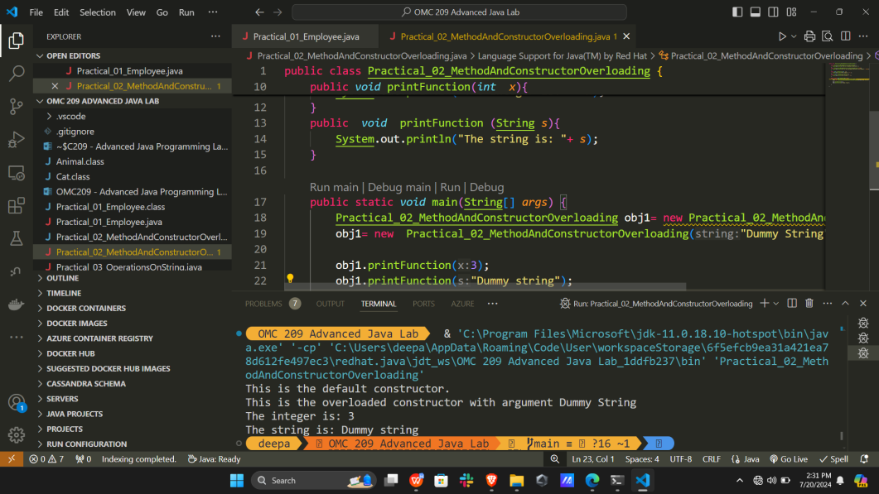

Program 3:

Write a Java program to perform the following operations on a string.

1. Count the number of characters and digits.

b. Check whether the given string is palindrome or not.

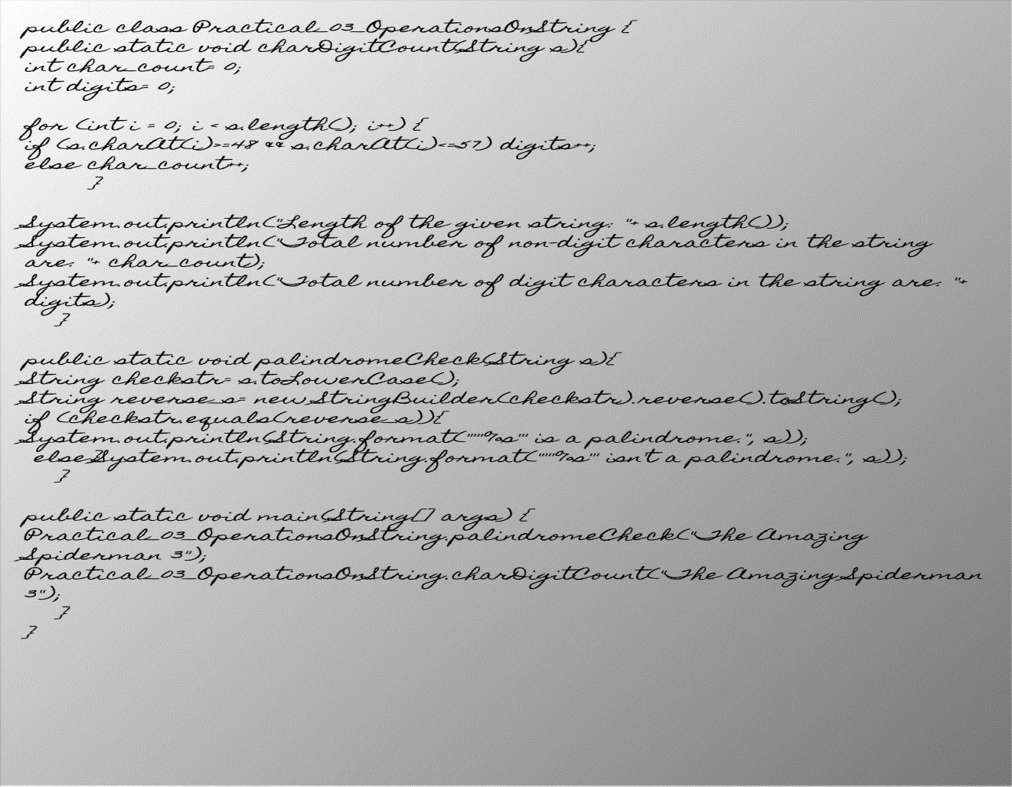

Output:

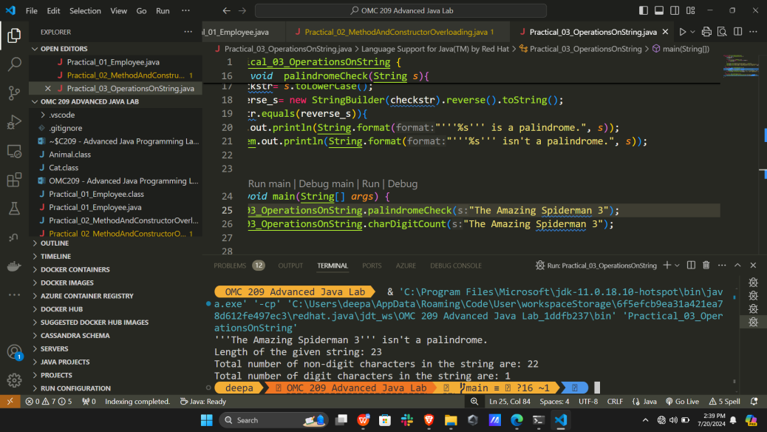

Program 4:

Write a Java program to demonstrate single and multi-level inheritance. Display the order of execution of constructors in multi-level inheritance.

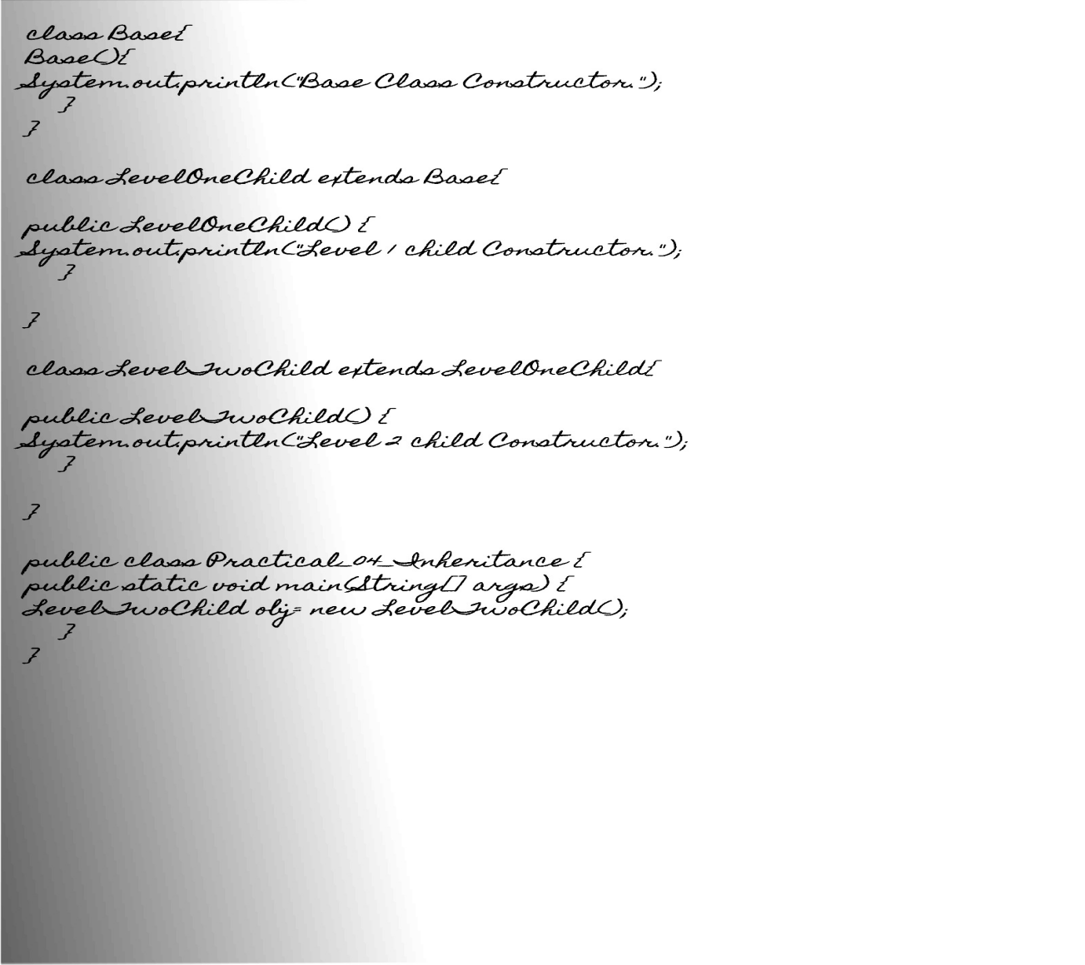

Output:

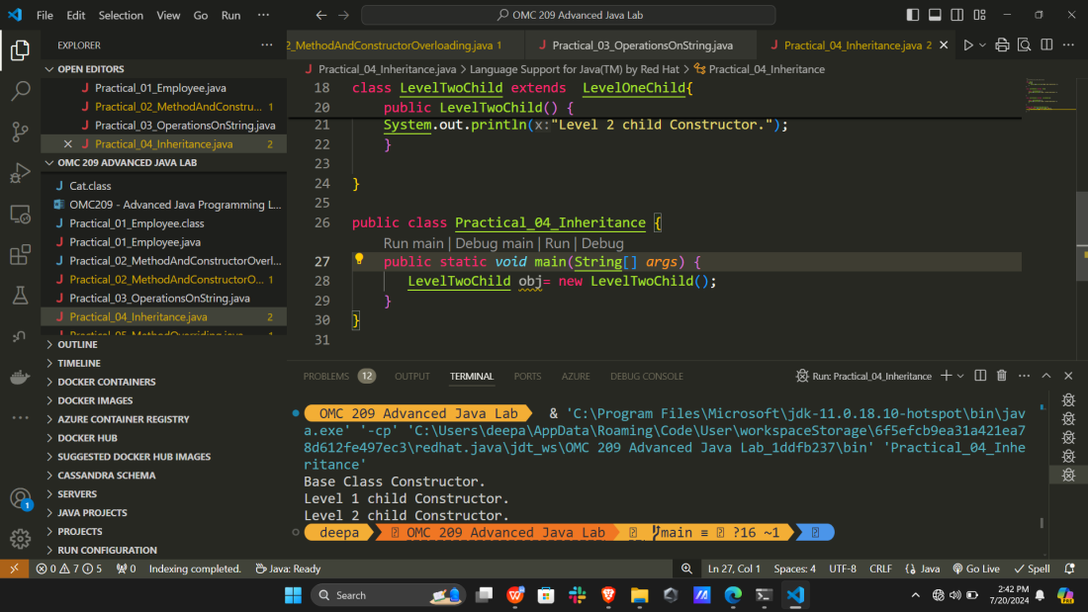

Program 5:

Write a Java program to demonstrate method overriding.

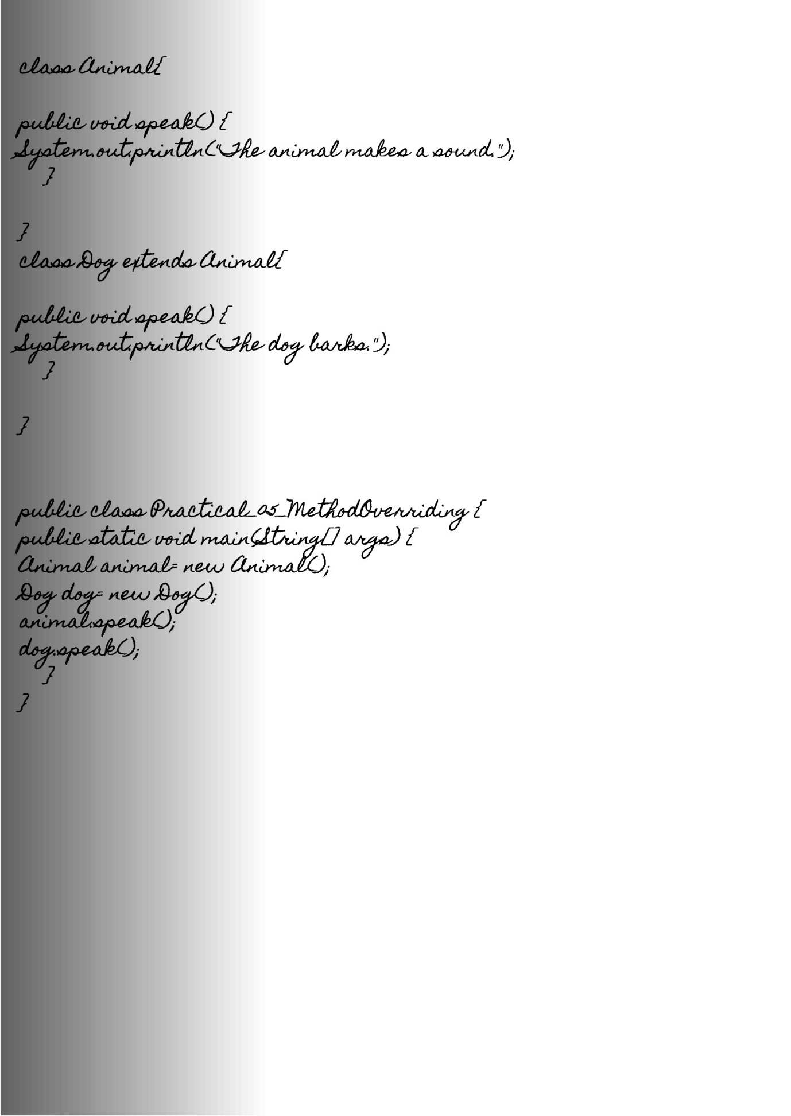

Output:

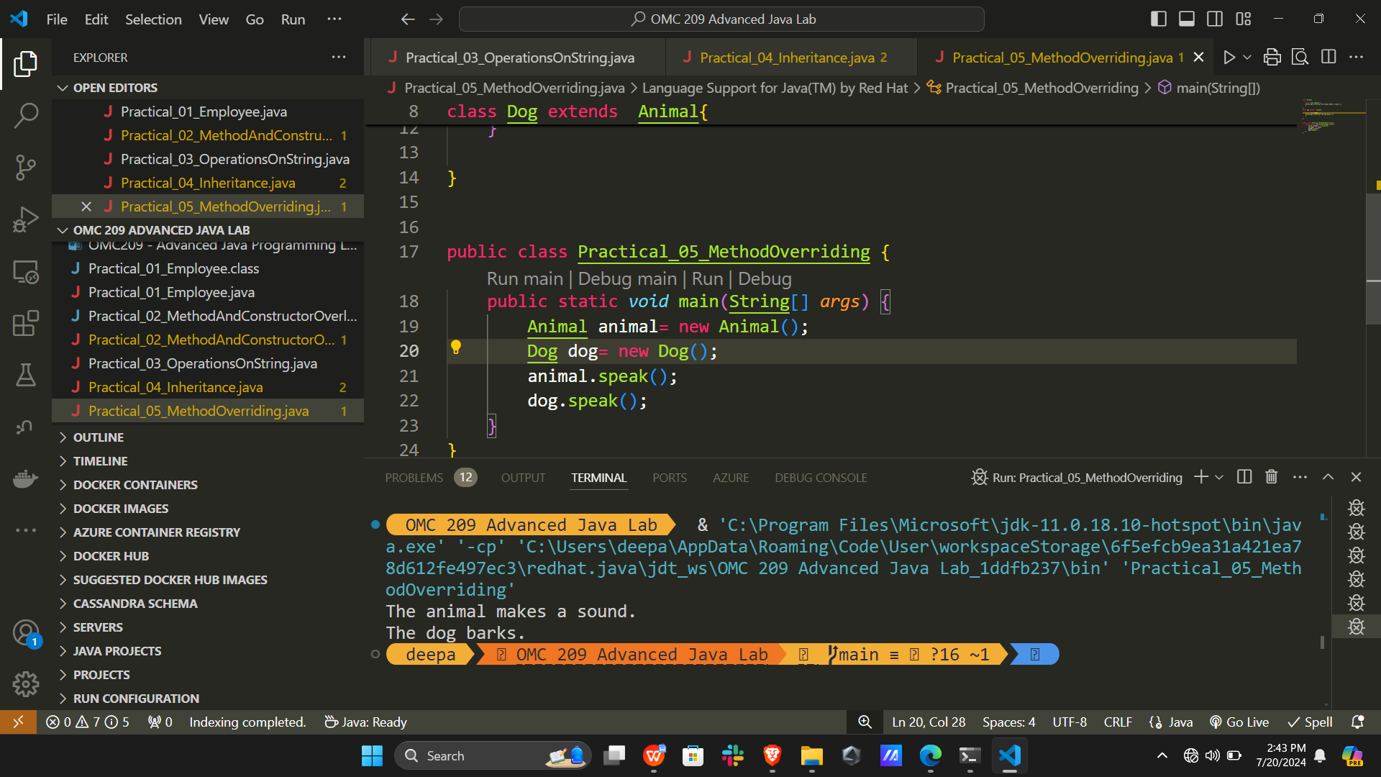

Program 6:

Write a Java program to illustrate the use of

1. Abstract class
2. Interfaces in Java

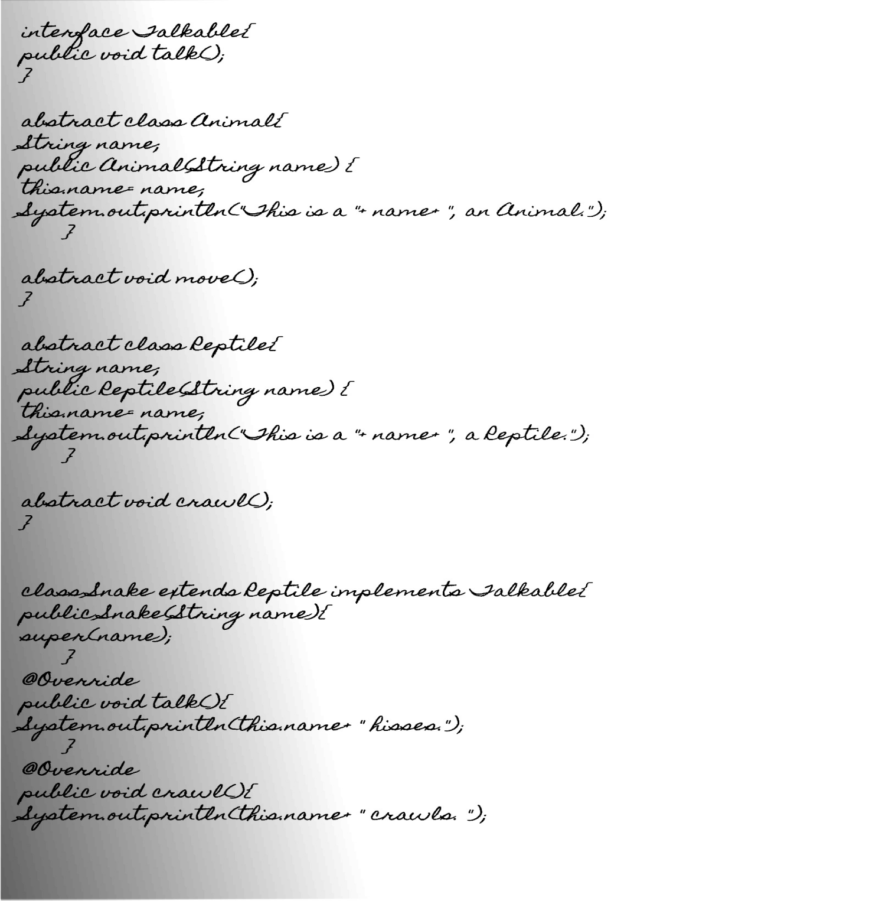

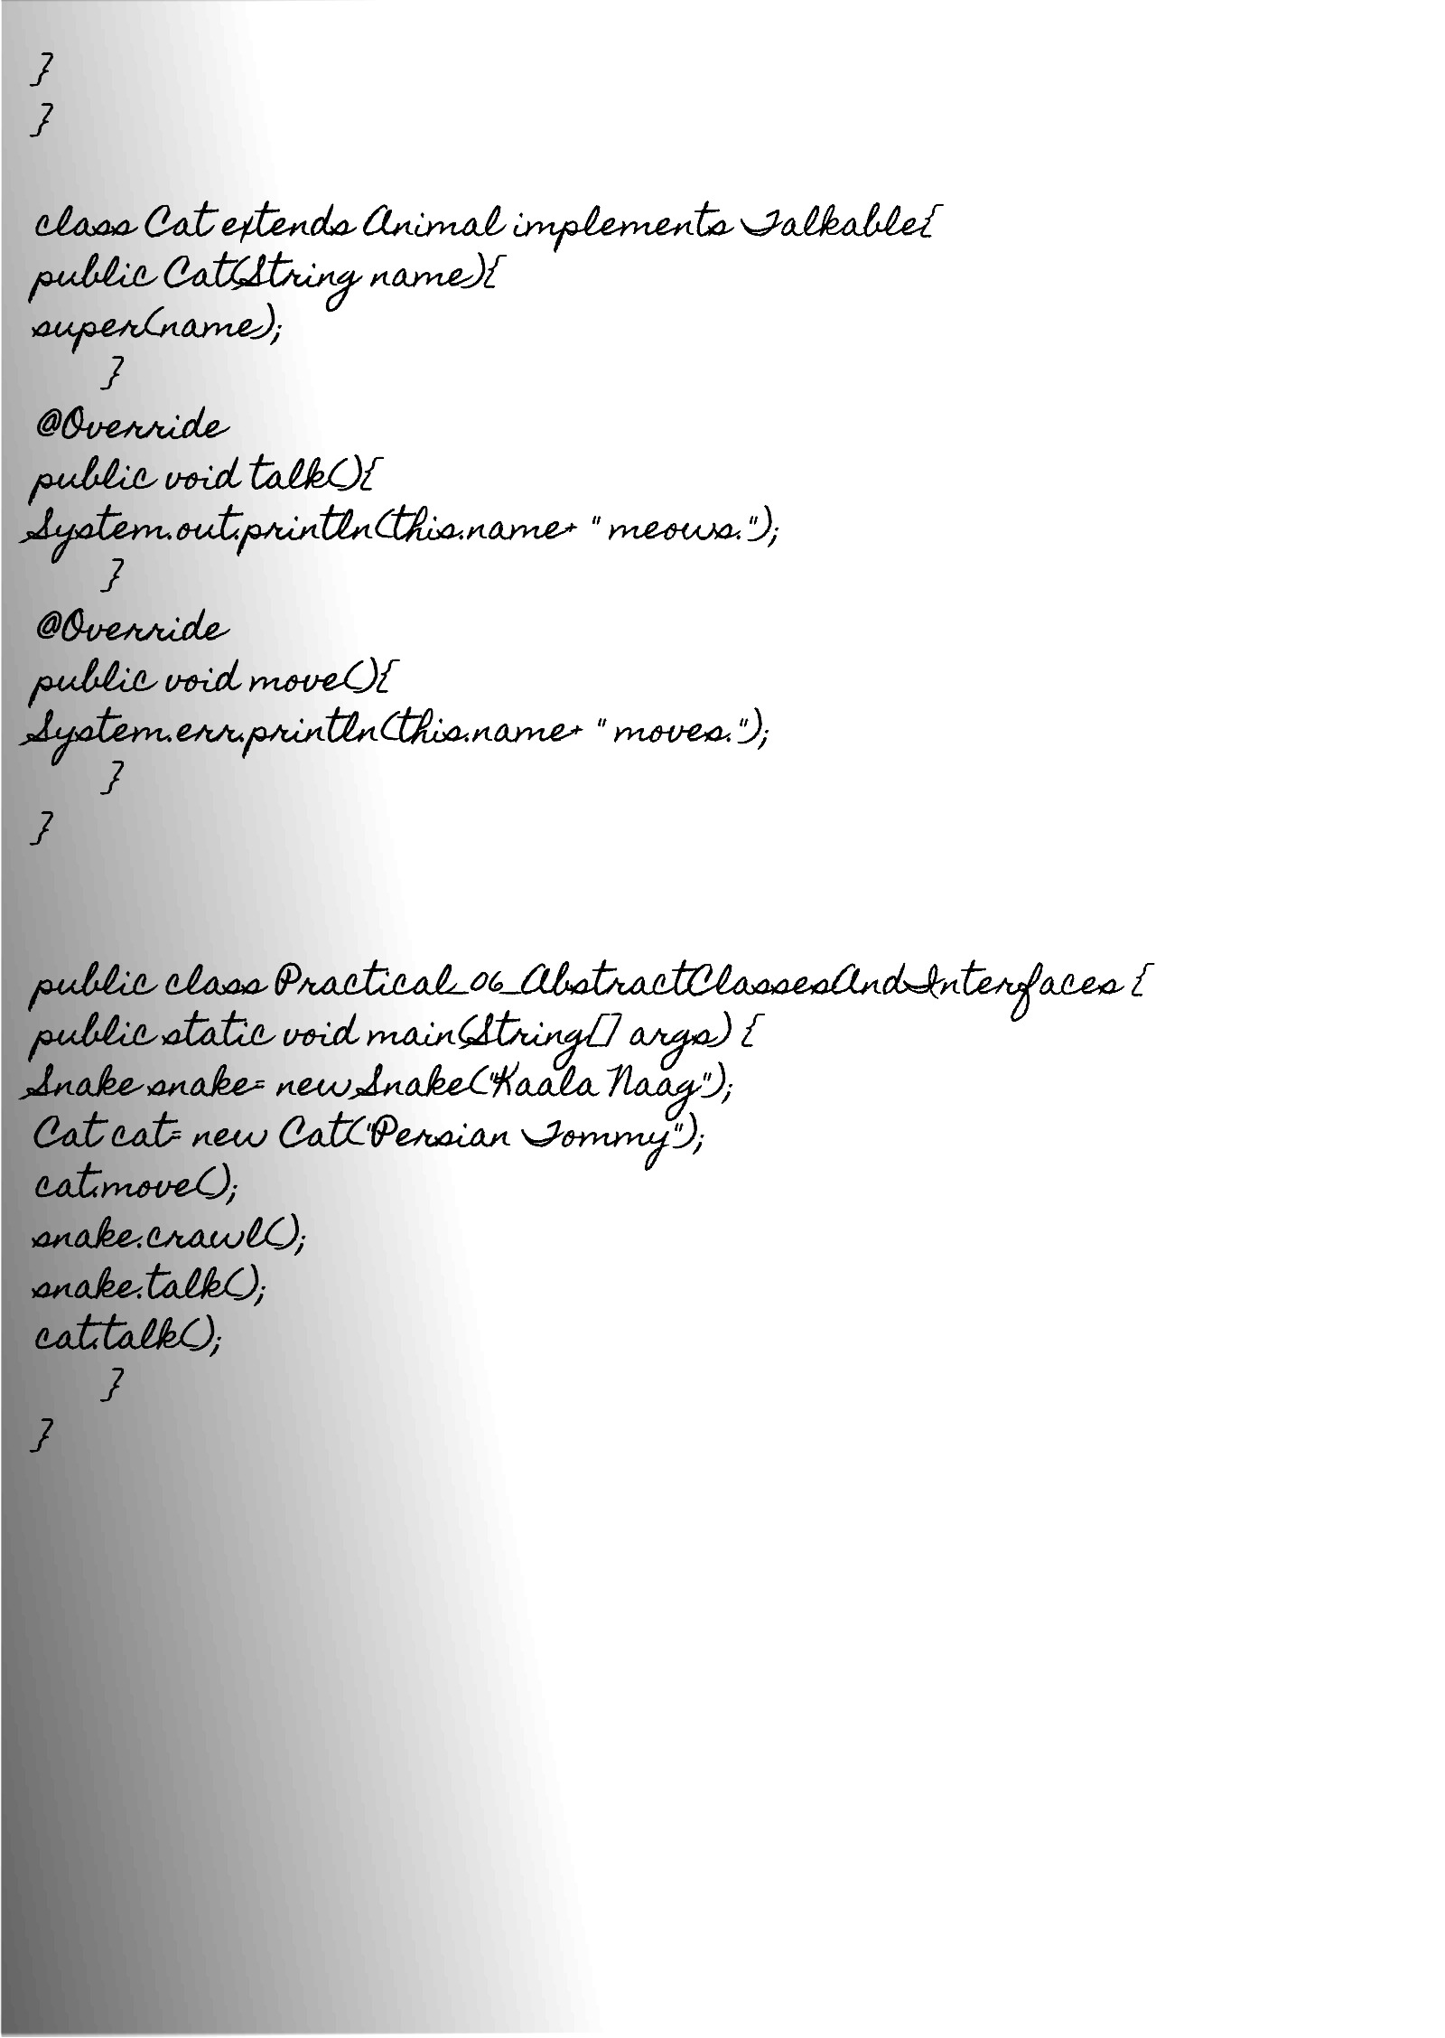

Output:

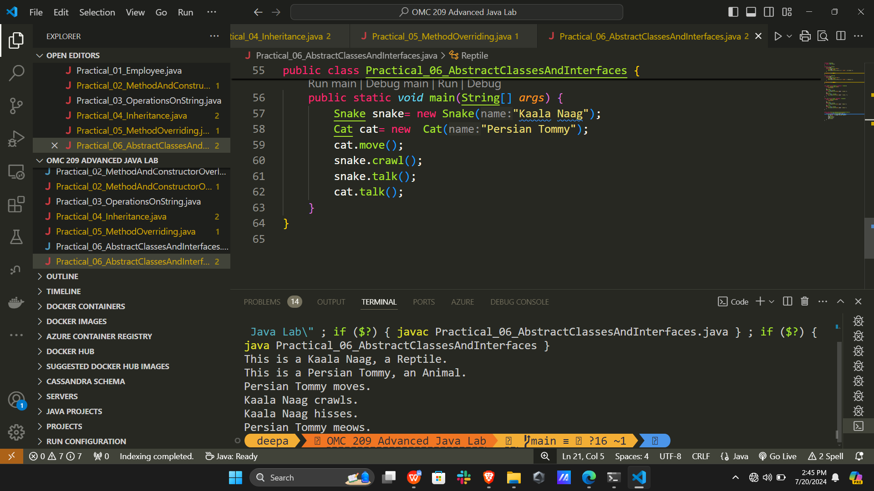

Program 7:

Write a Java program to demonstrate exception handling. Show the order of execution of “try”, “catch” and “finally” blocks when an exception occurs and when it does not occur during the execution by providing appropriate inputs during execution and displaying messages.

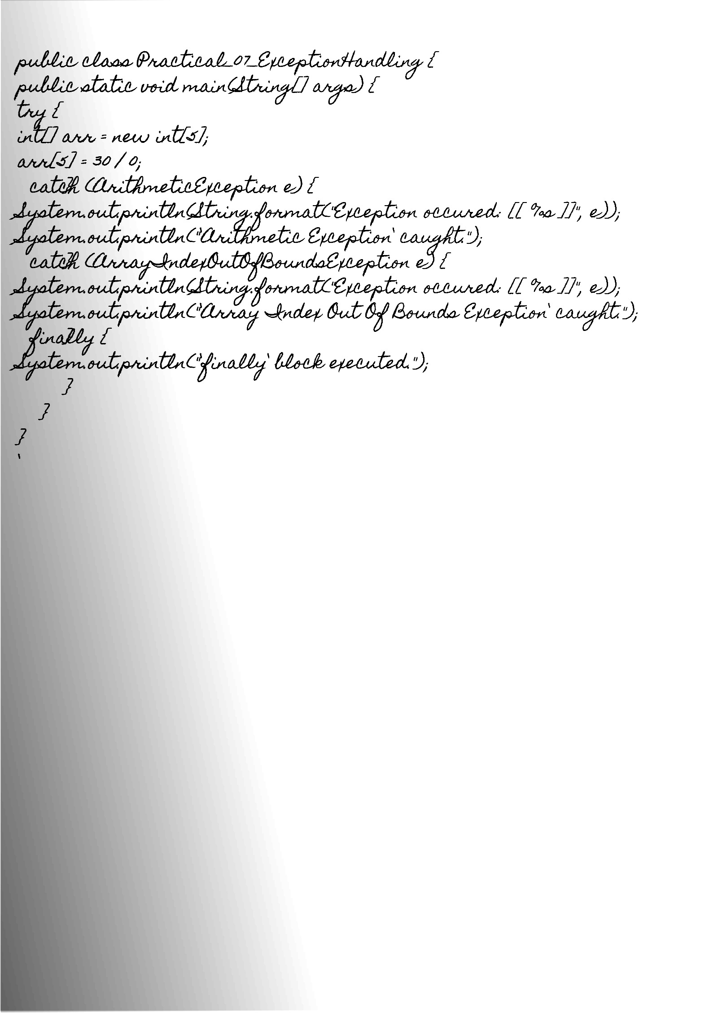

Output:

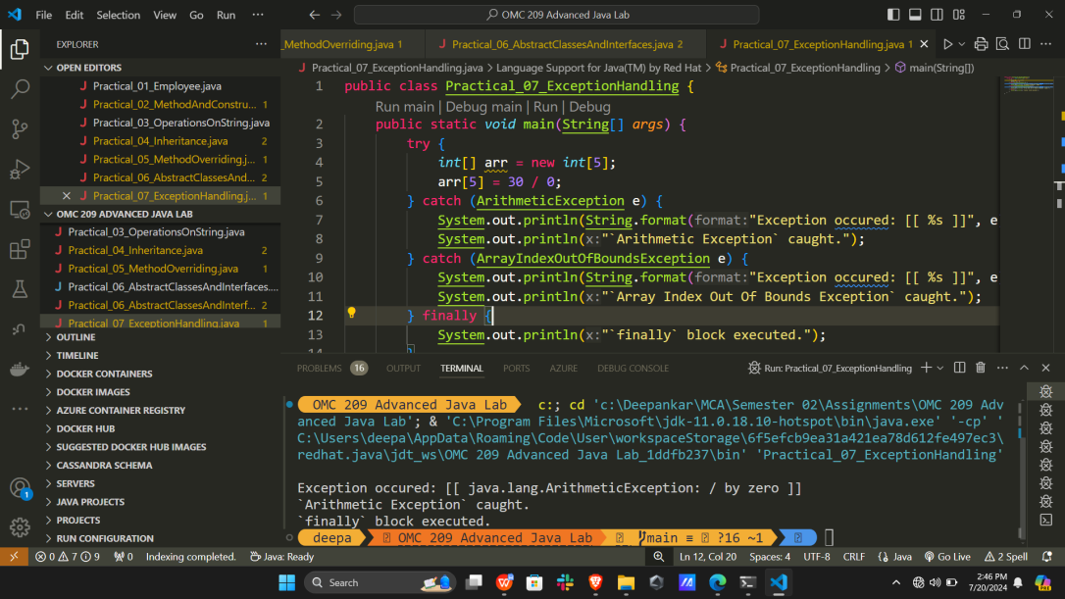

Program 8:

Write a Java program to illustrate the use of I/O streams.

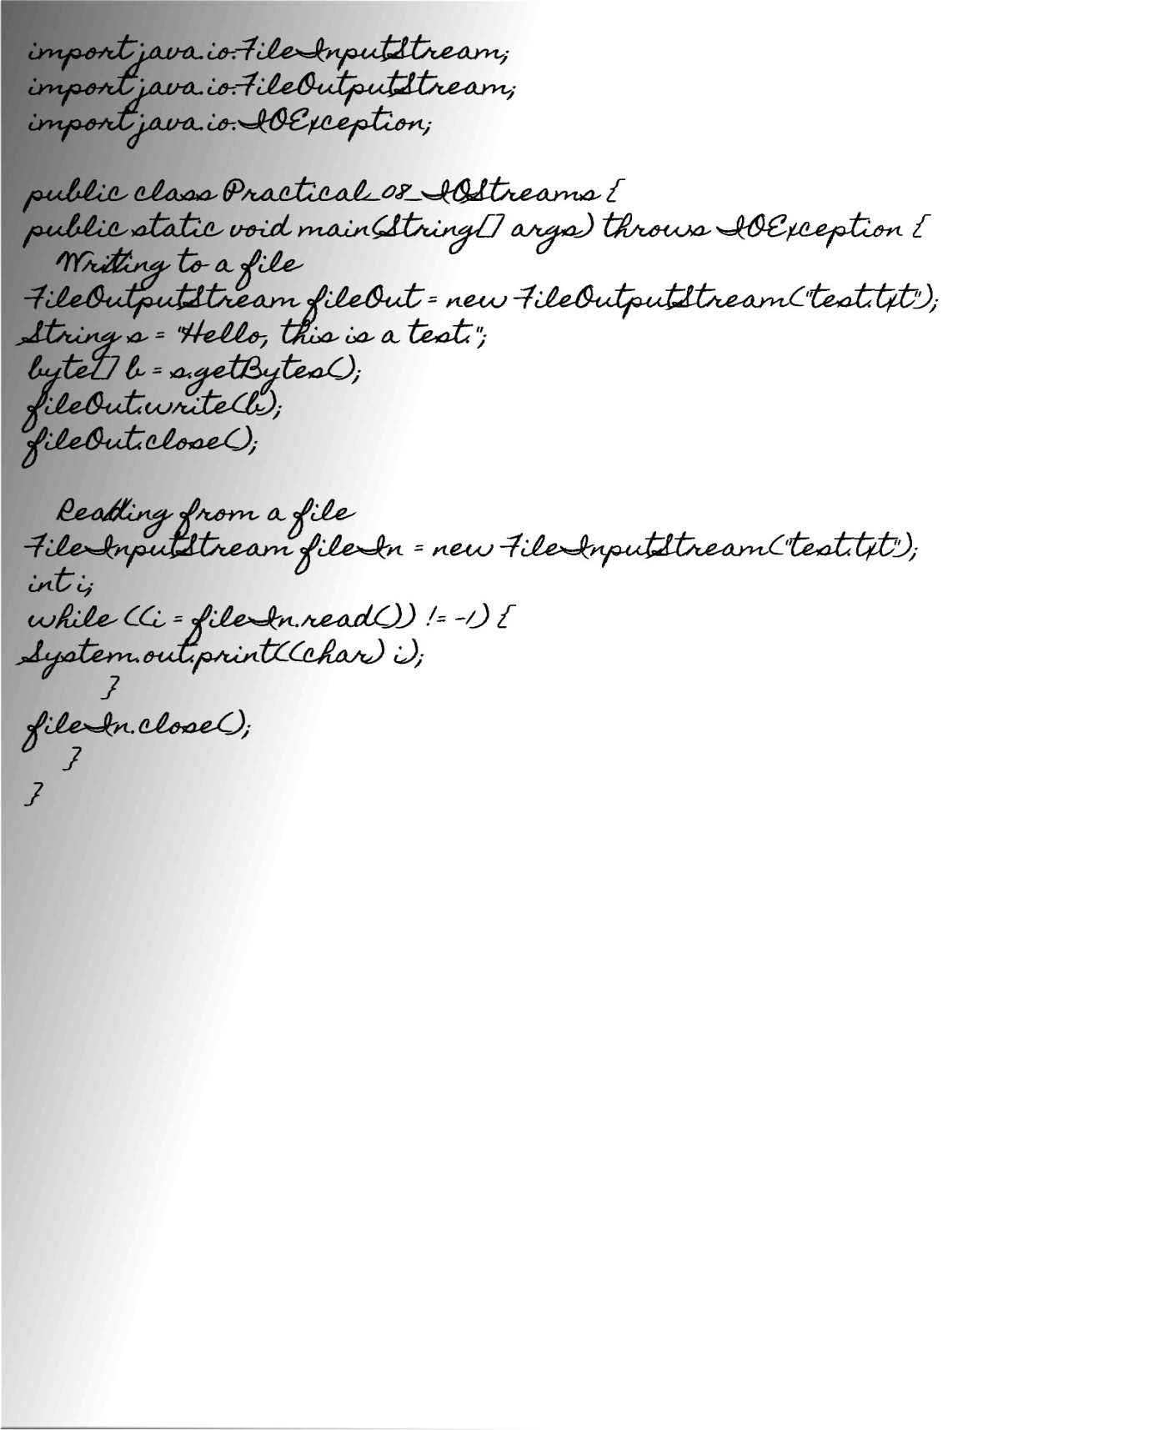

Output:

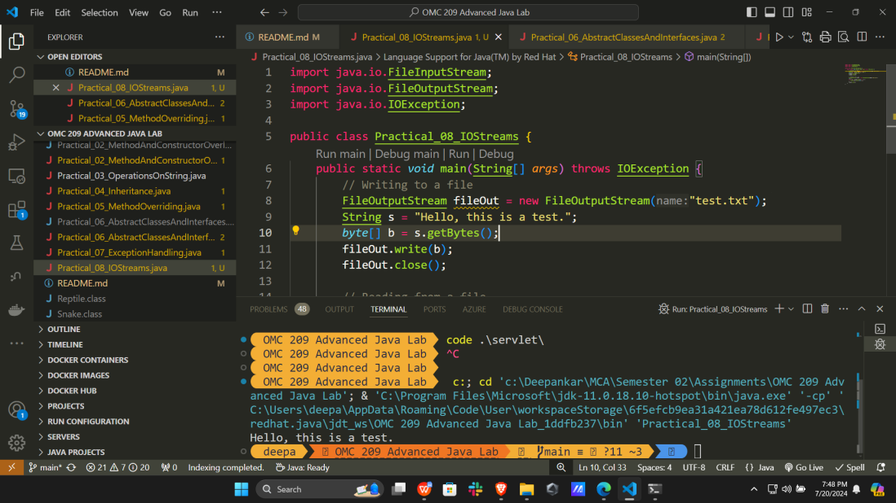

Program 9:

Write a Java Servlet program to implement a dynamic HTML using Servlet( Student name and enrolment number should be accepted using HTML and displayed using a Servlet).

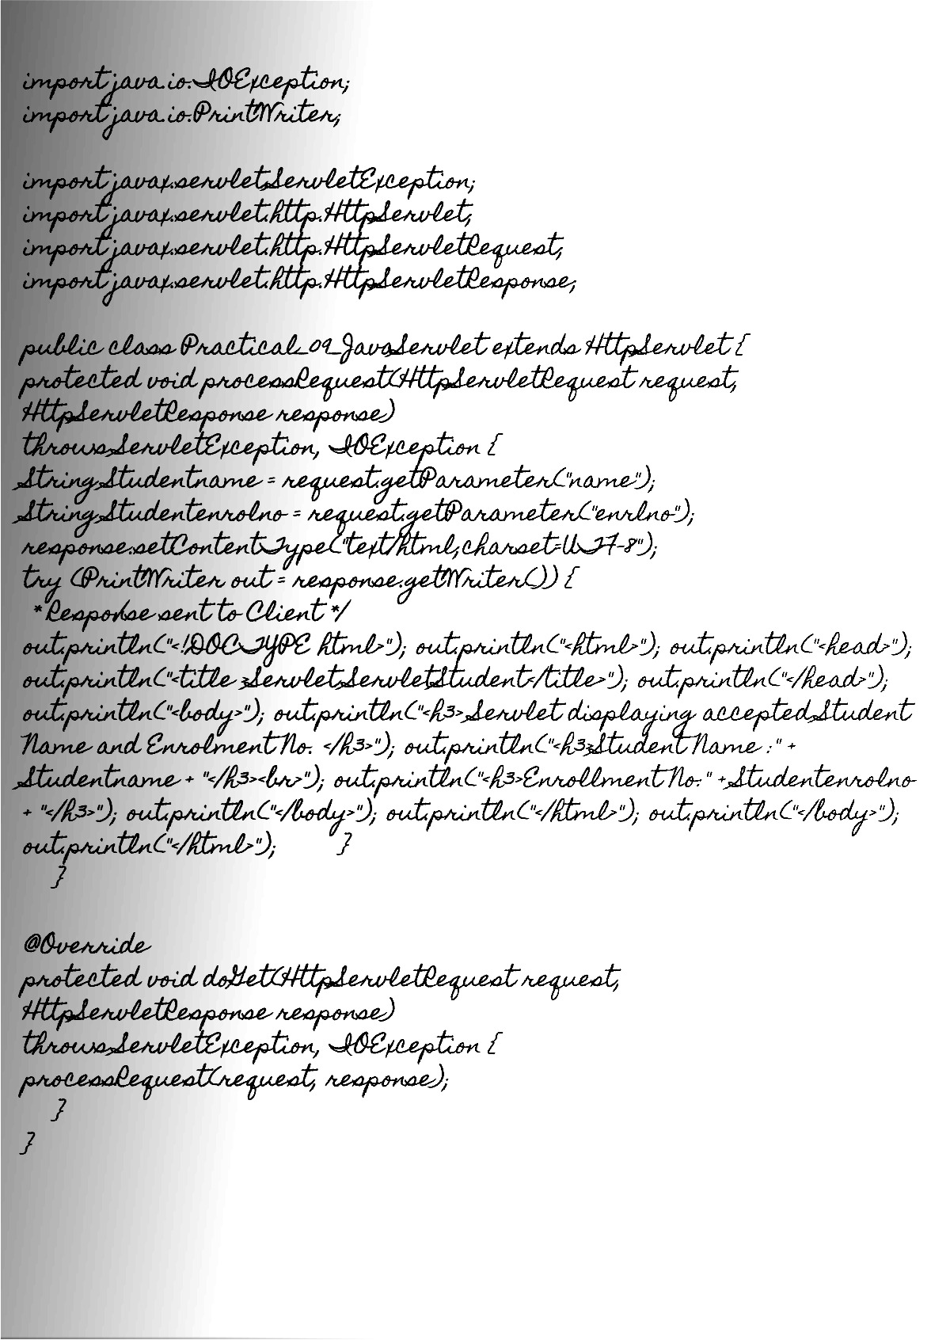

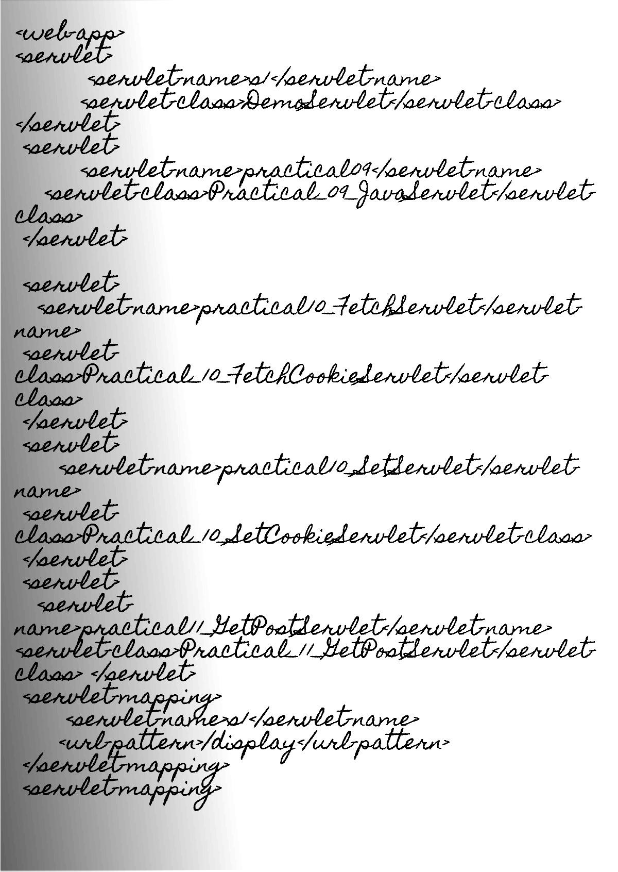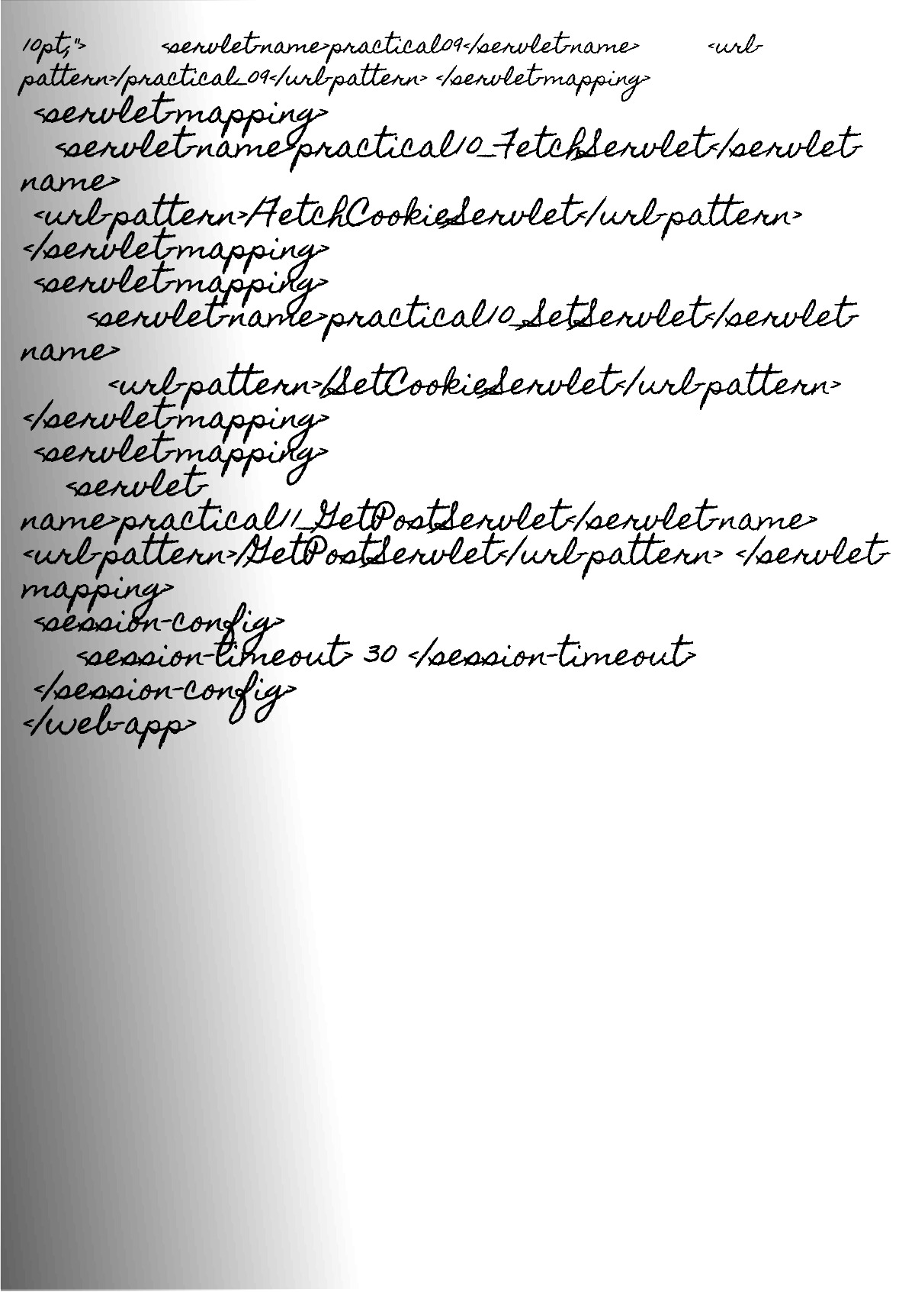

Output:

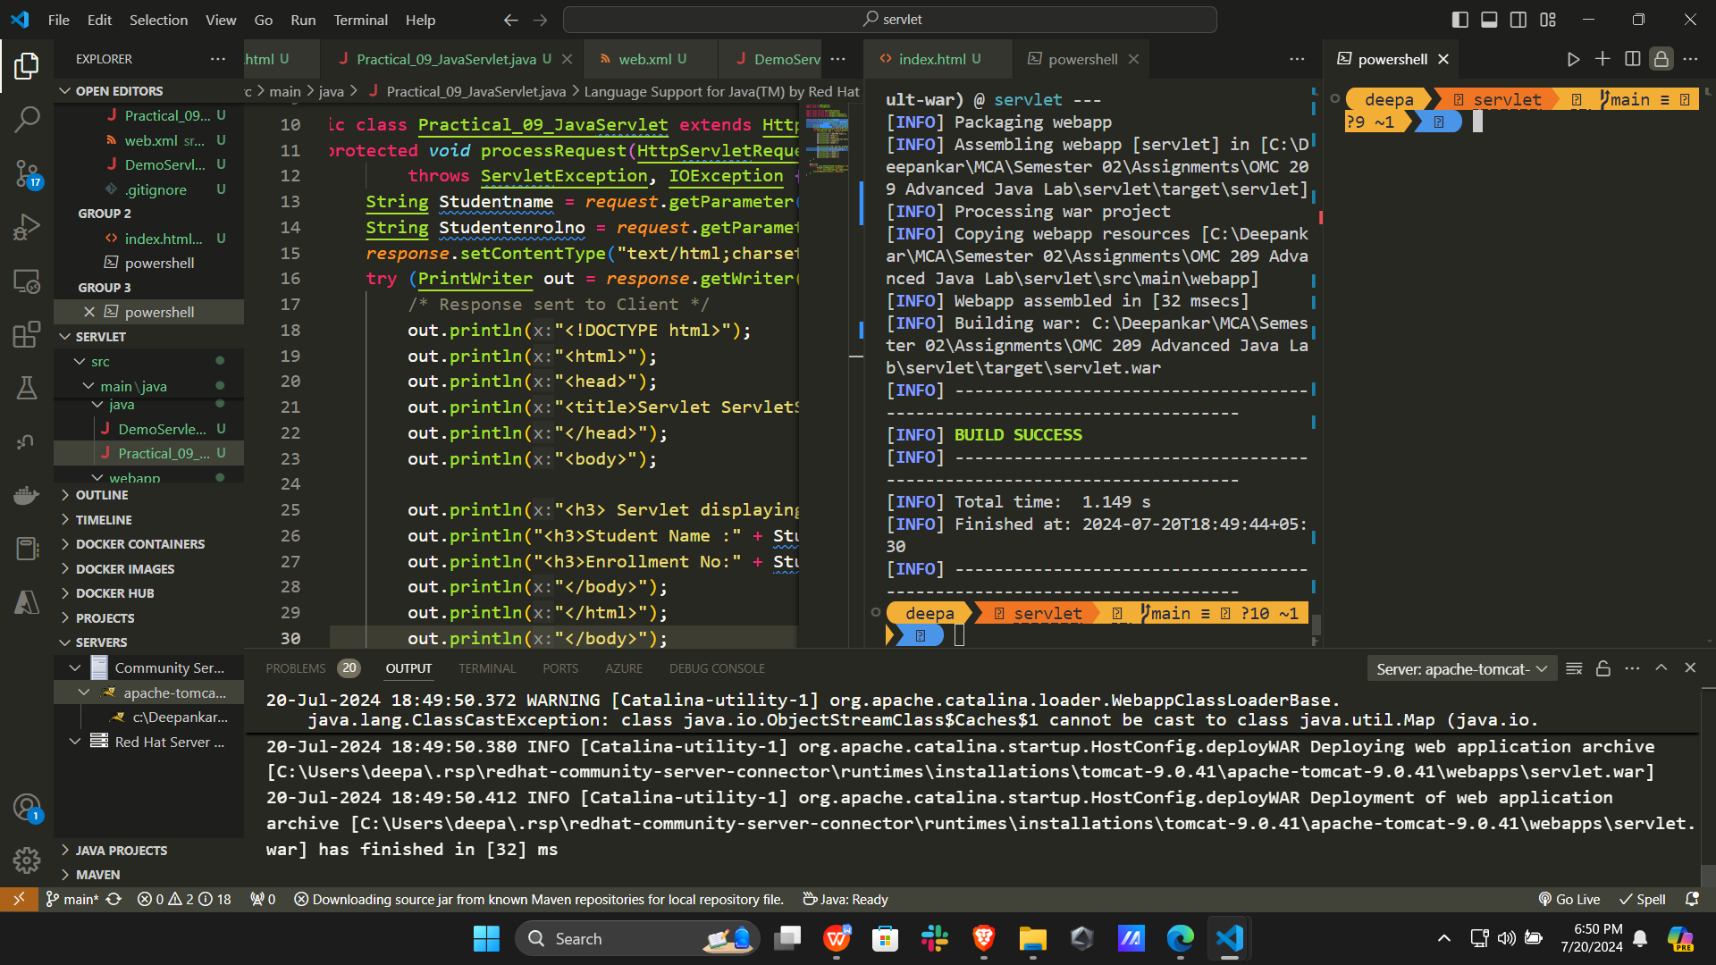

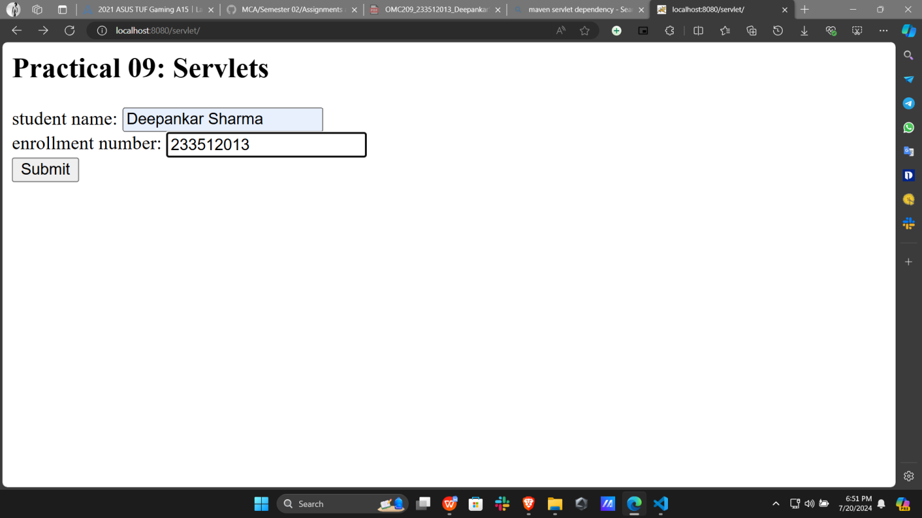

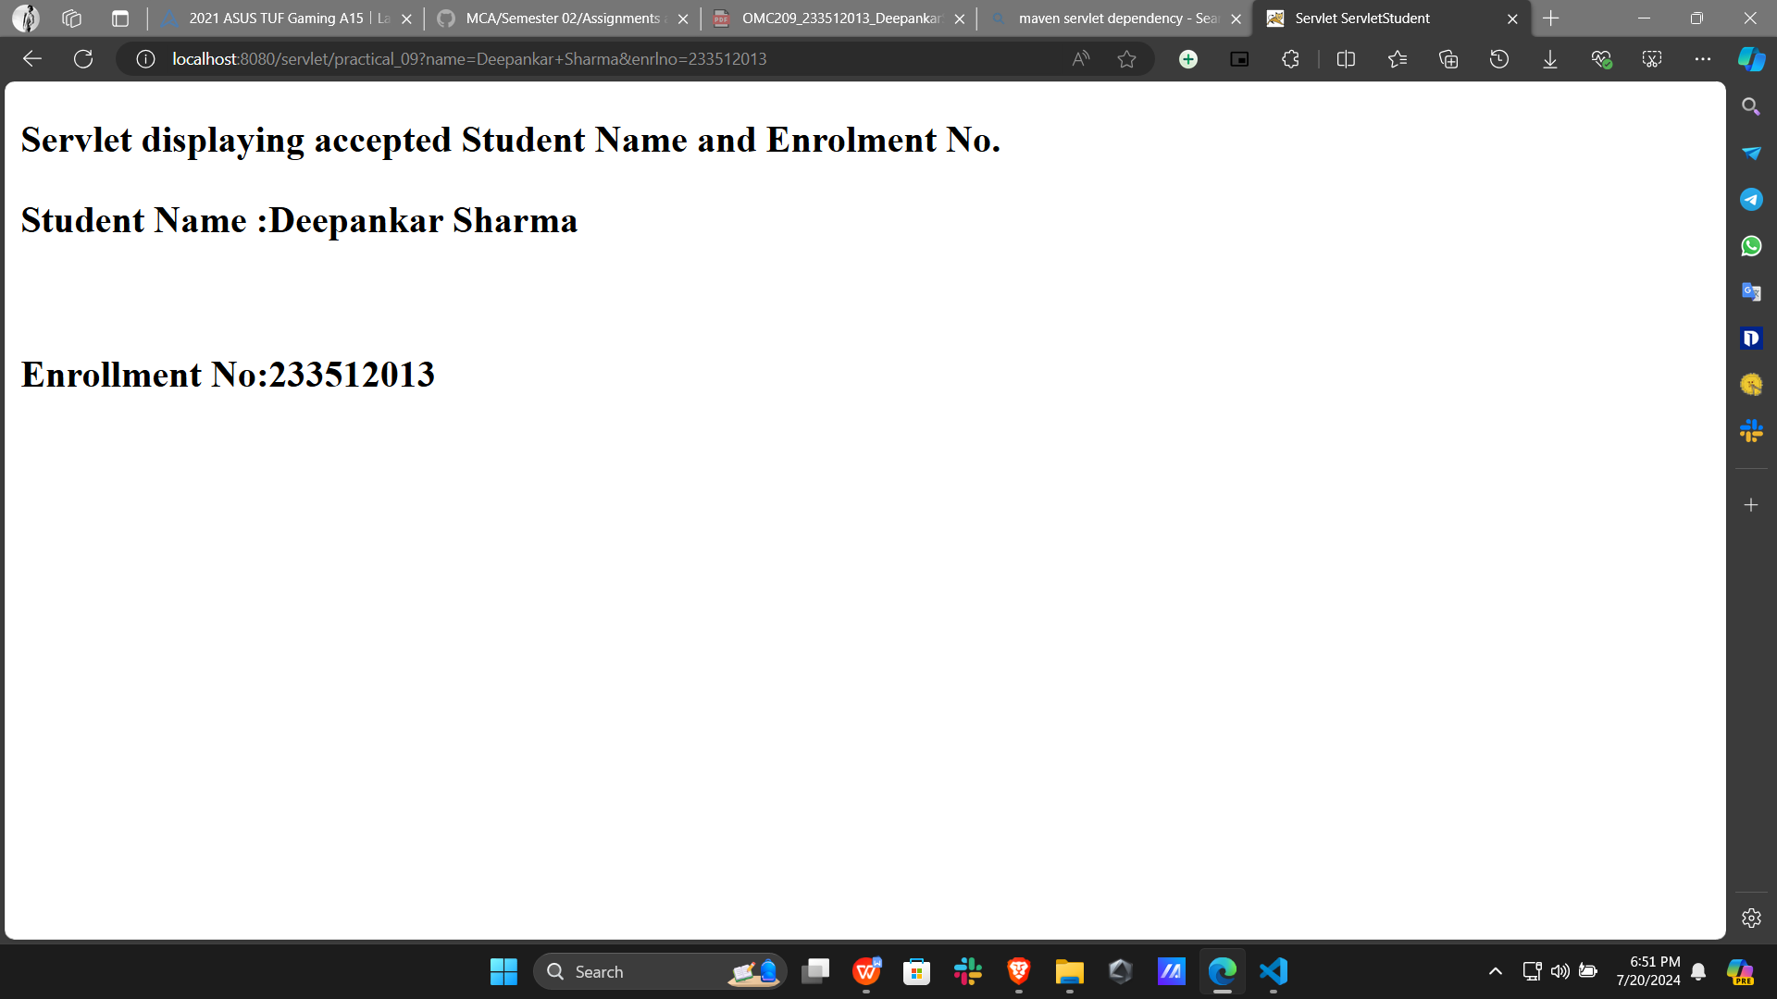

Program 10:

Write a Java Servlet program to demonstrate the use of cookies.

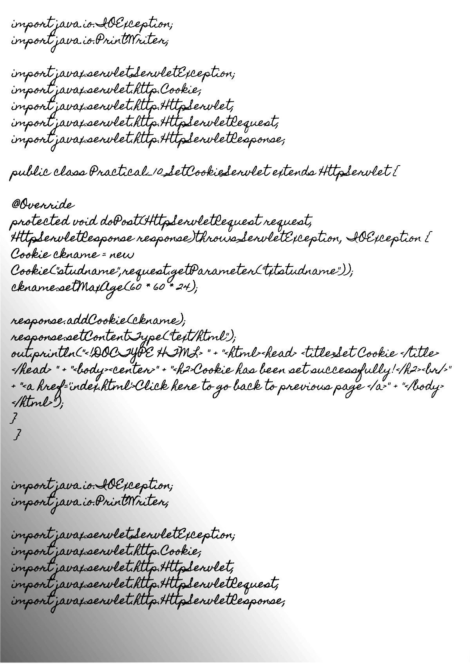

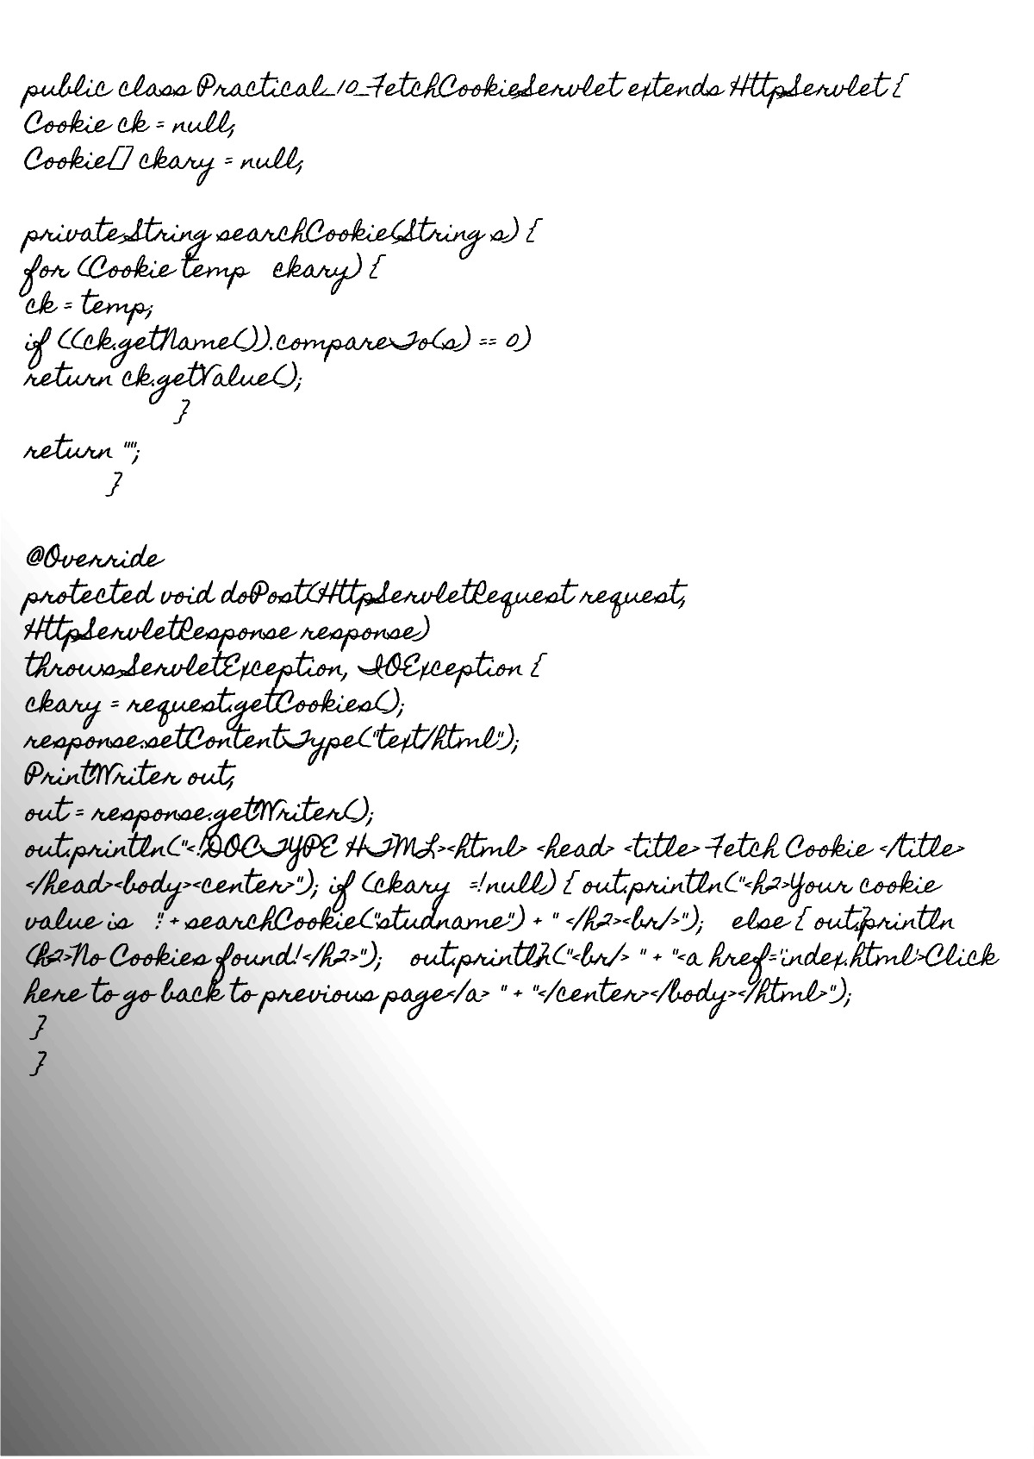

Output:

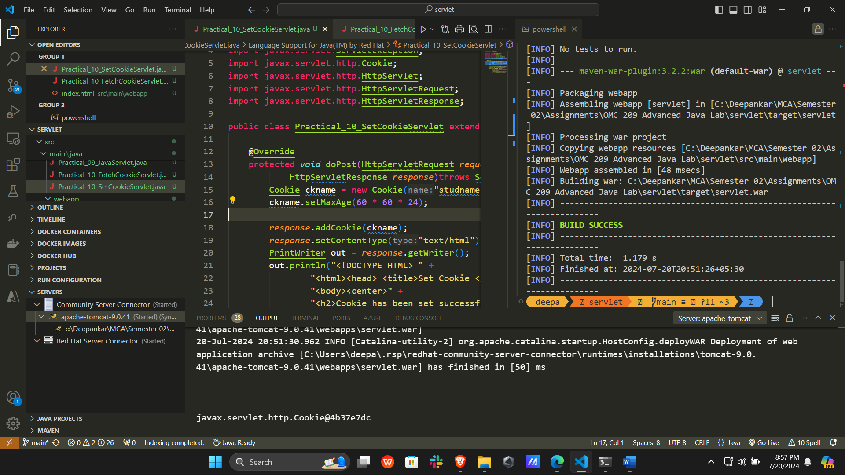

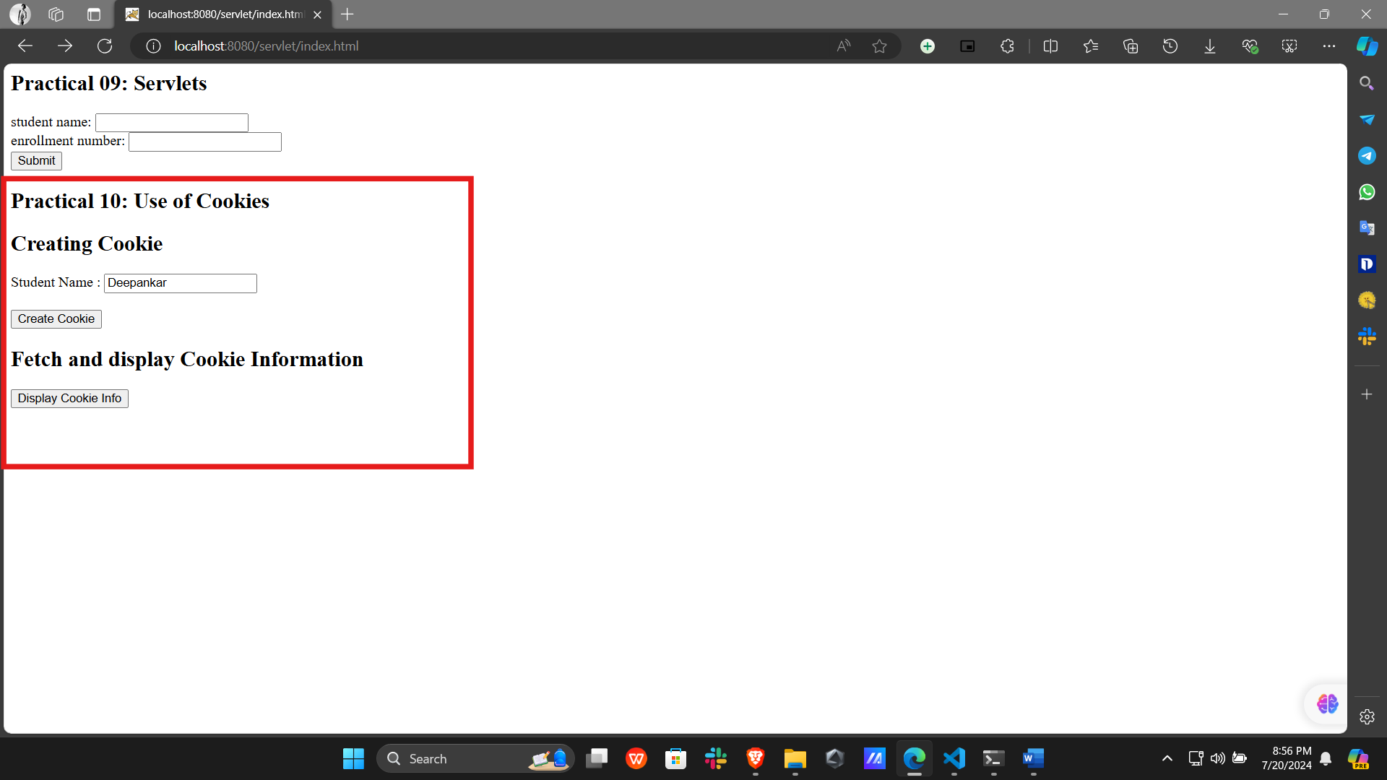

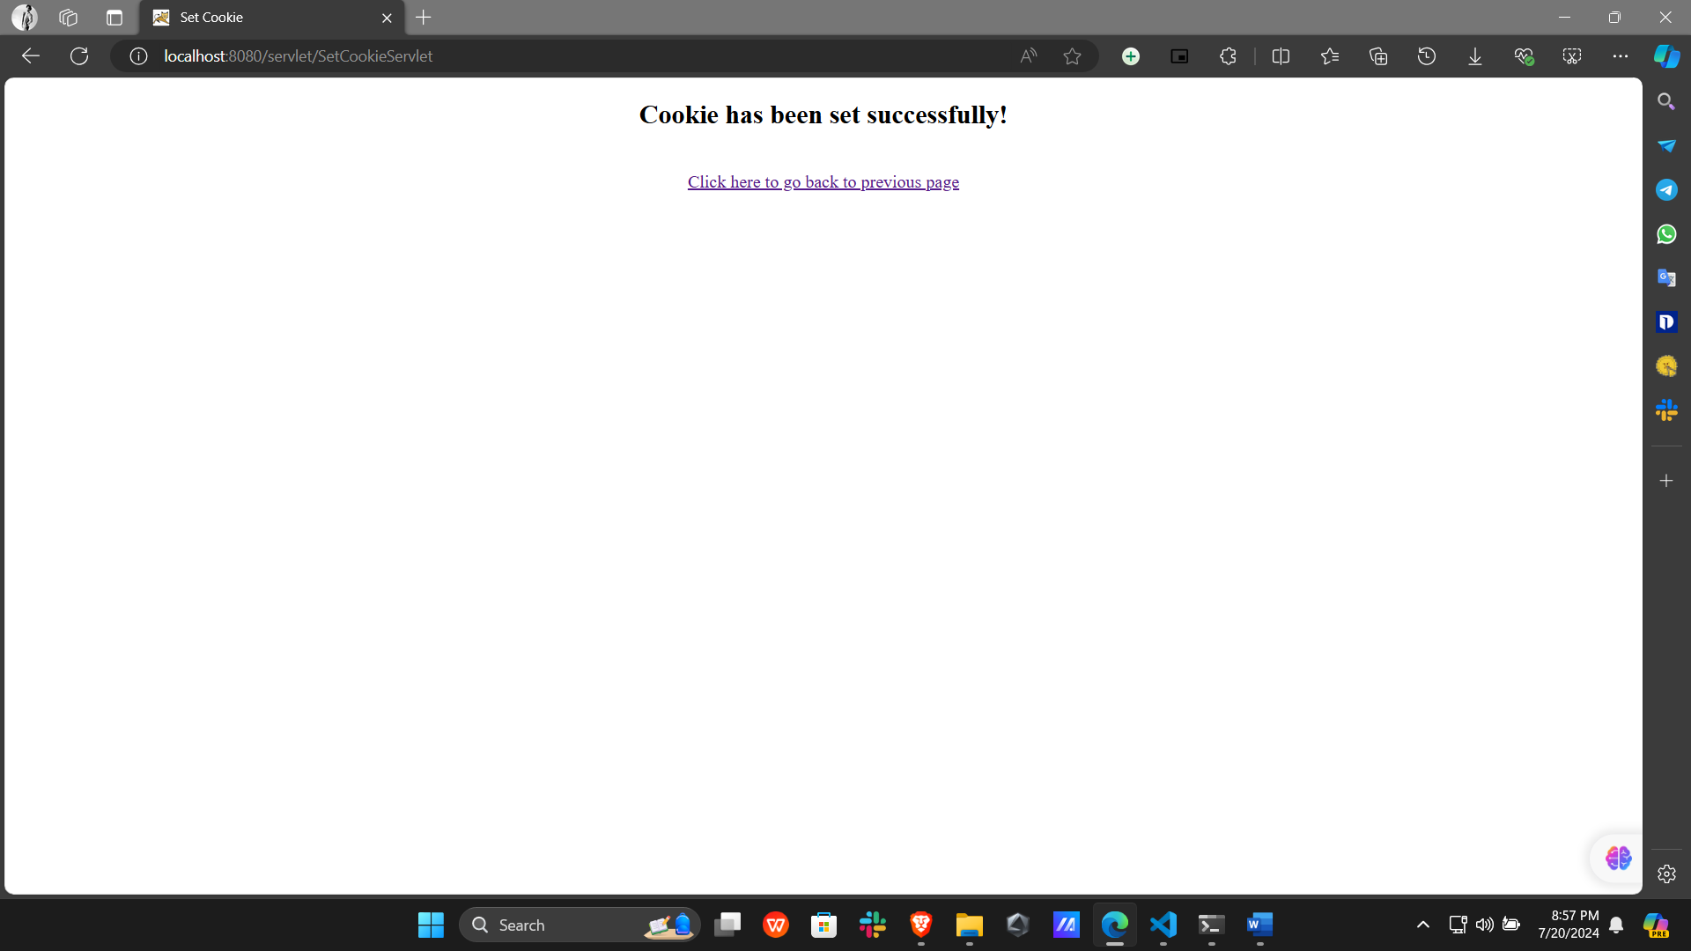

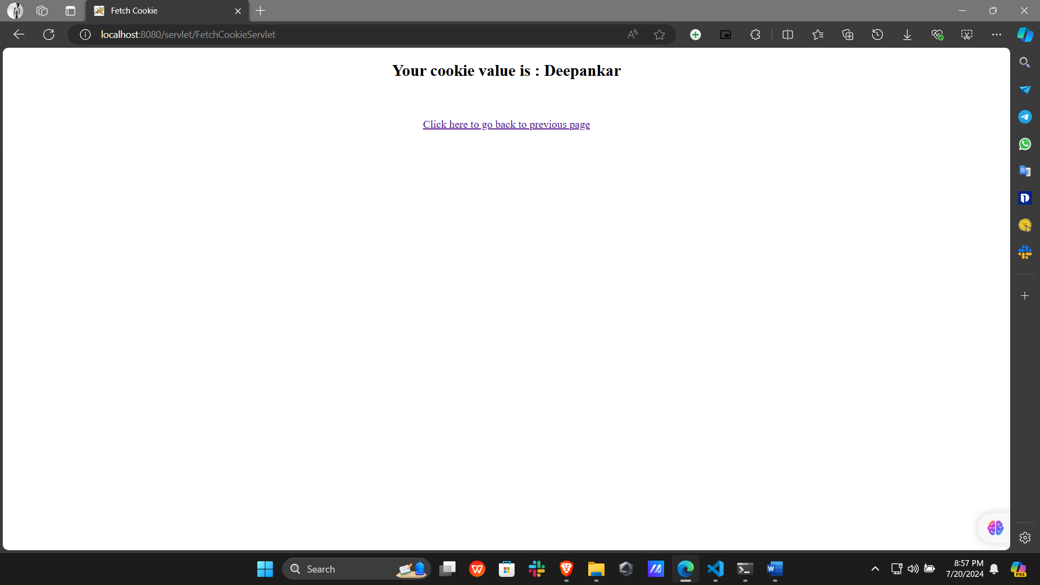

Program 11:

Write a Java Servlet program to demonstrate the use of GET and POST methods for handling HTTP client requests and server responses.

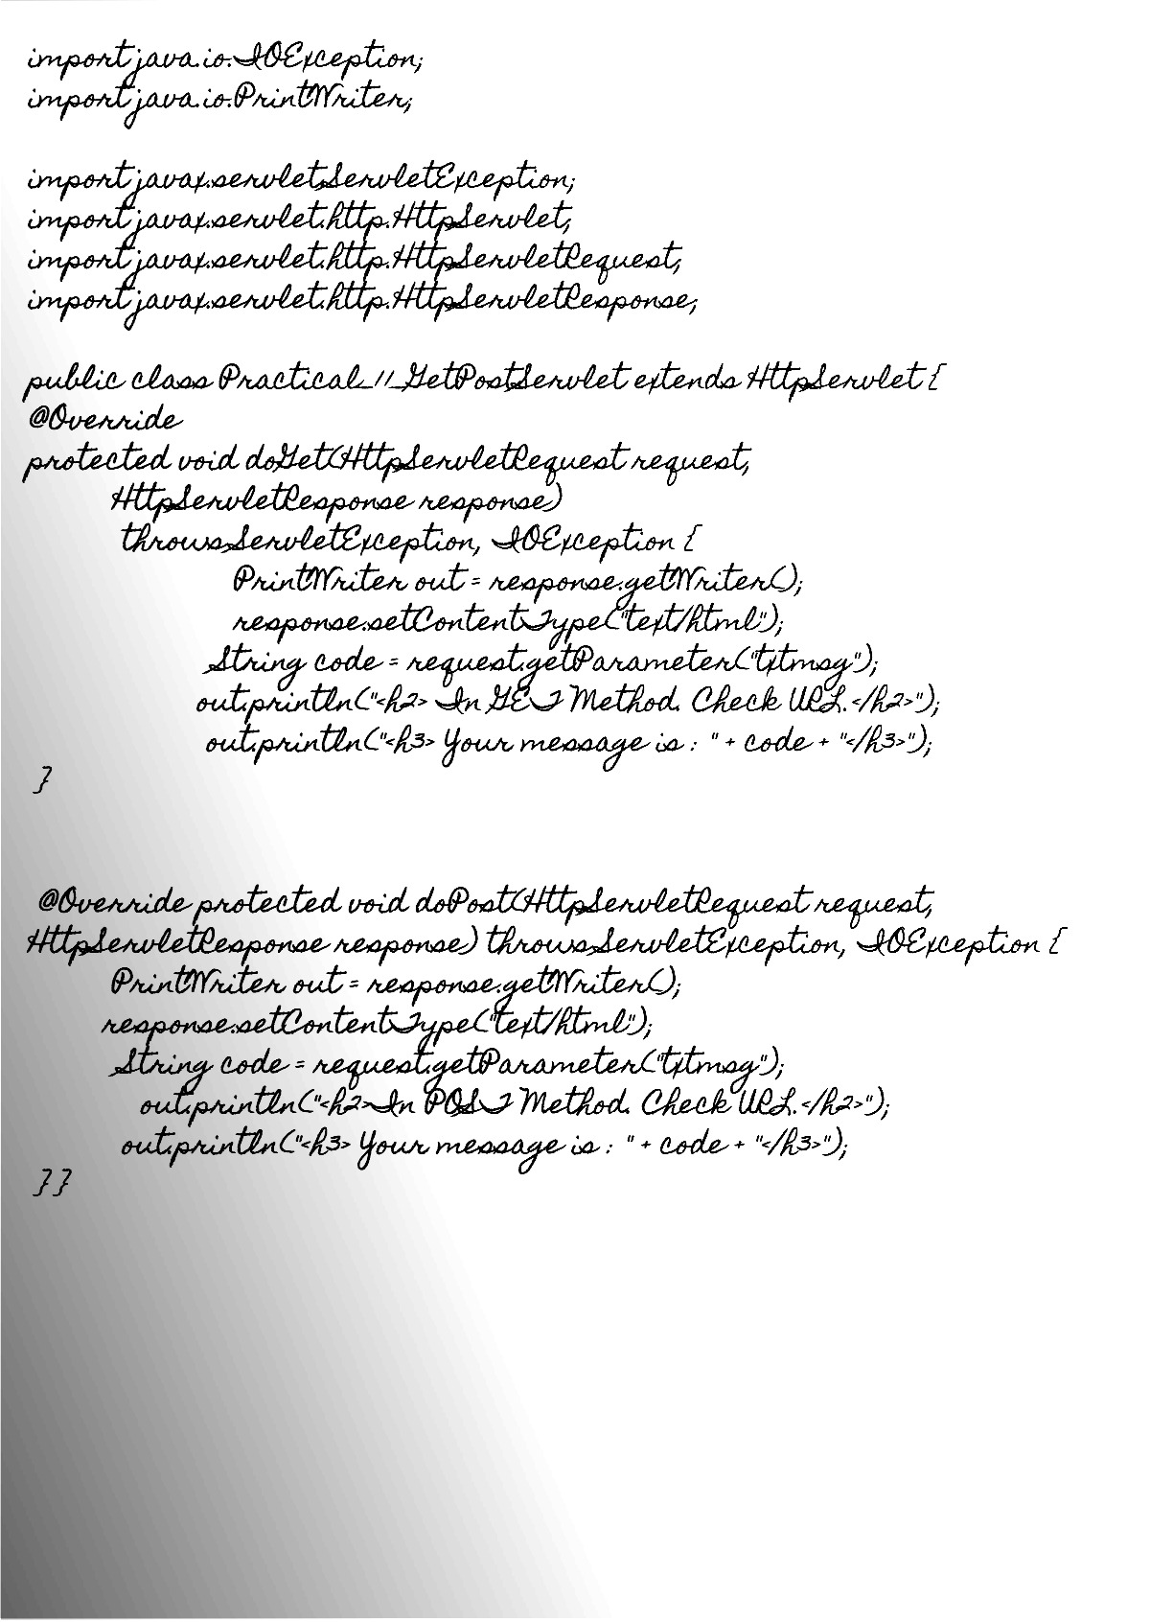

Output:

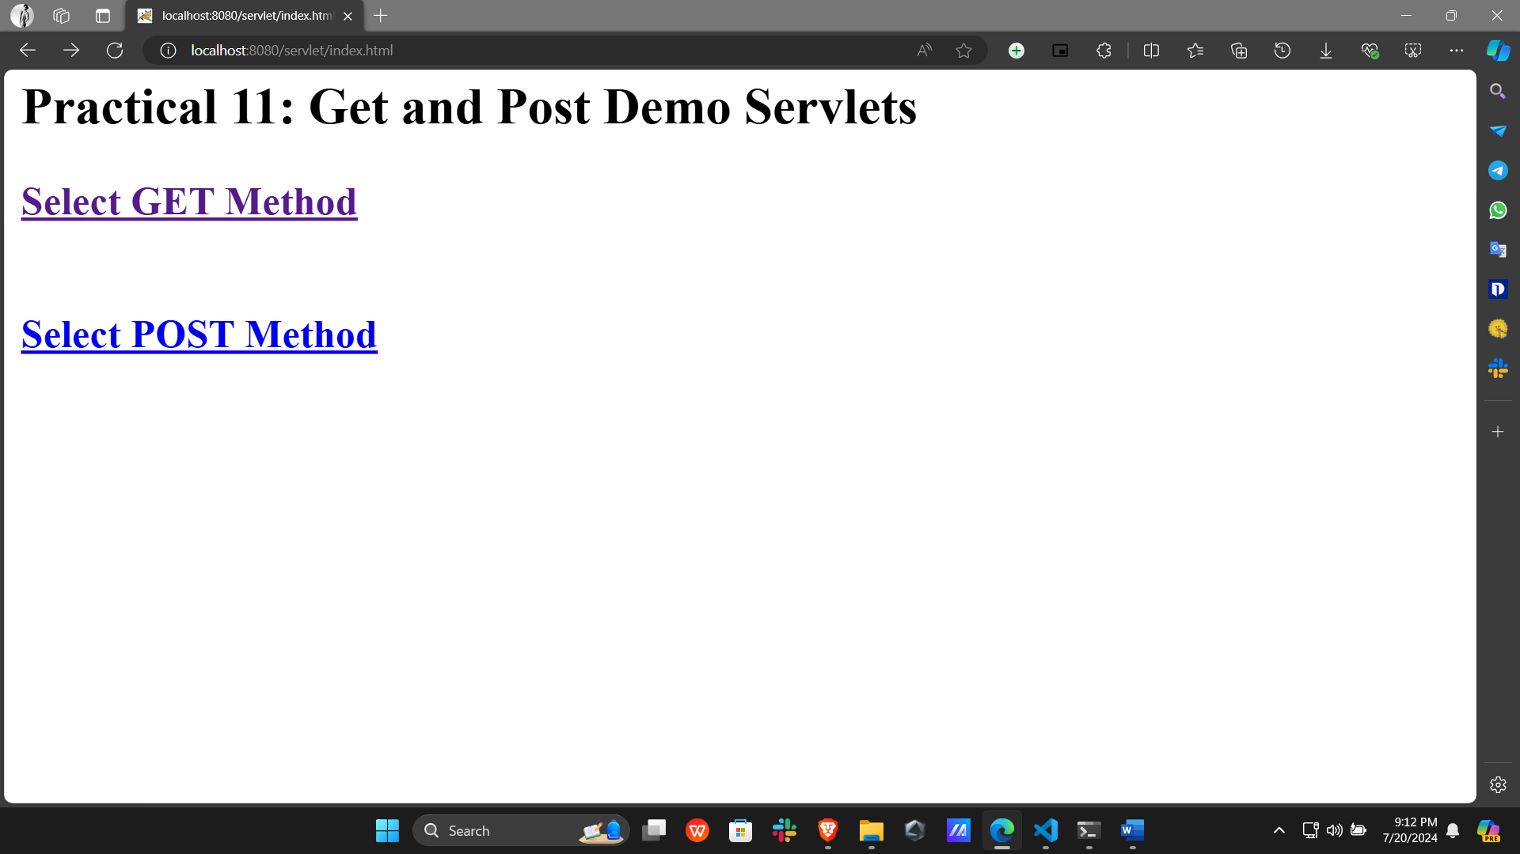

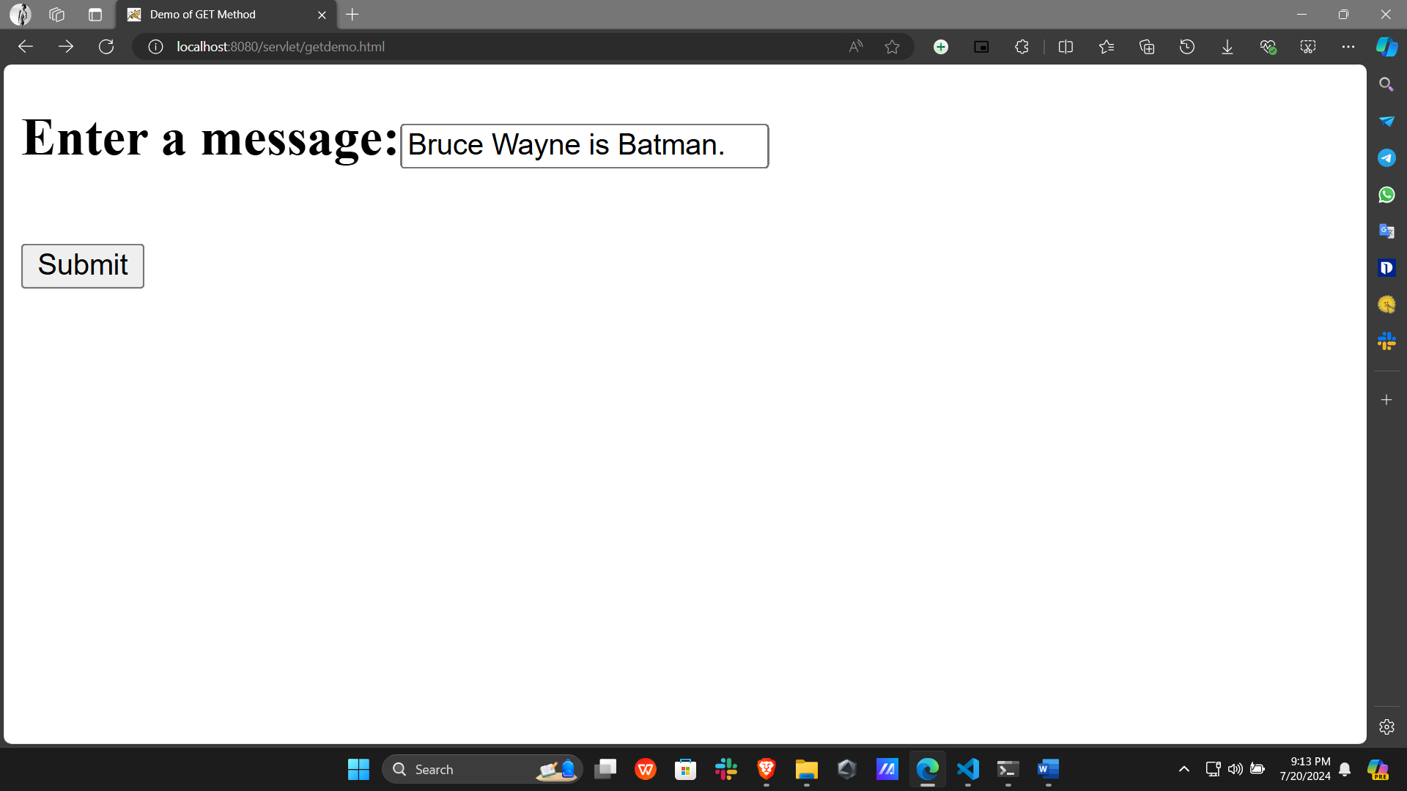

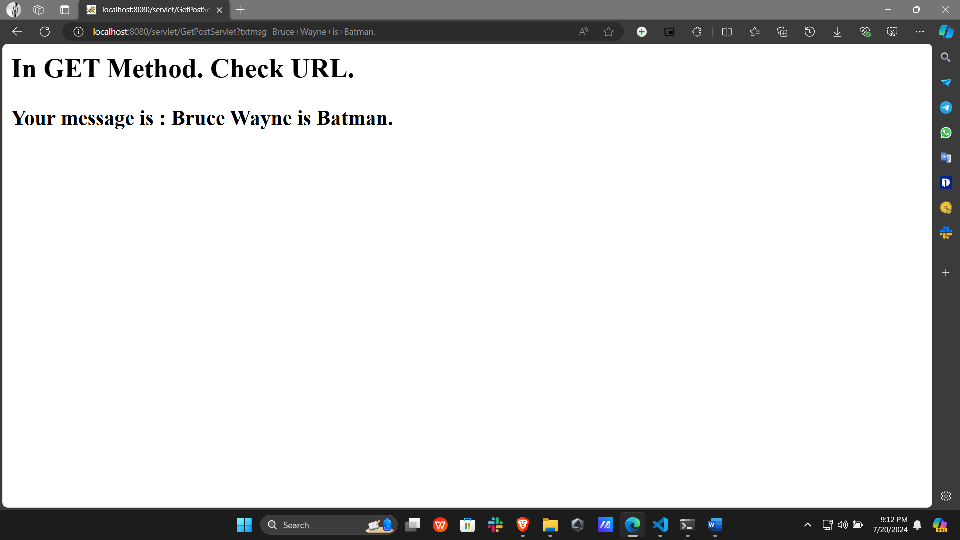

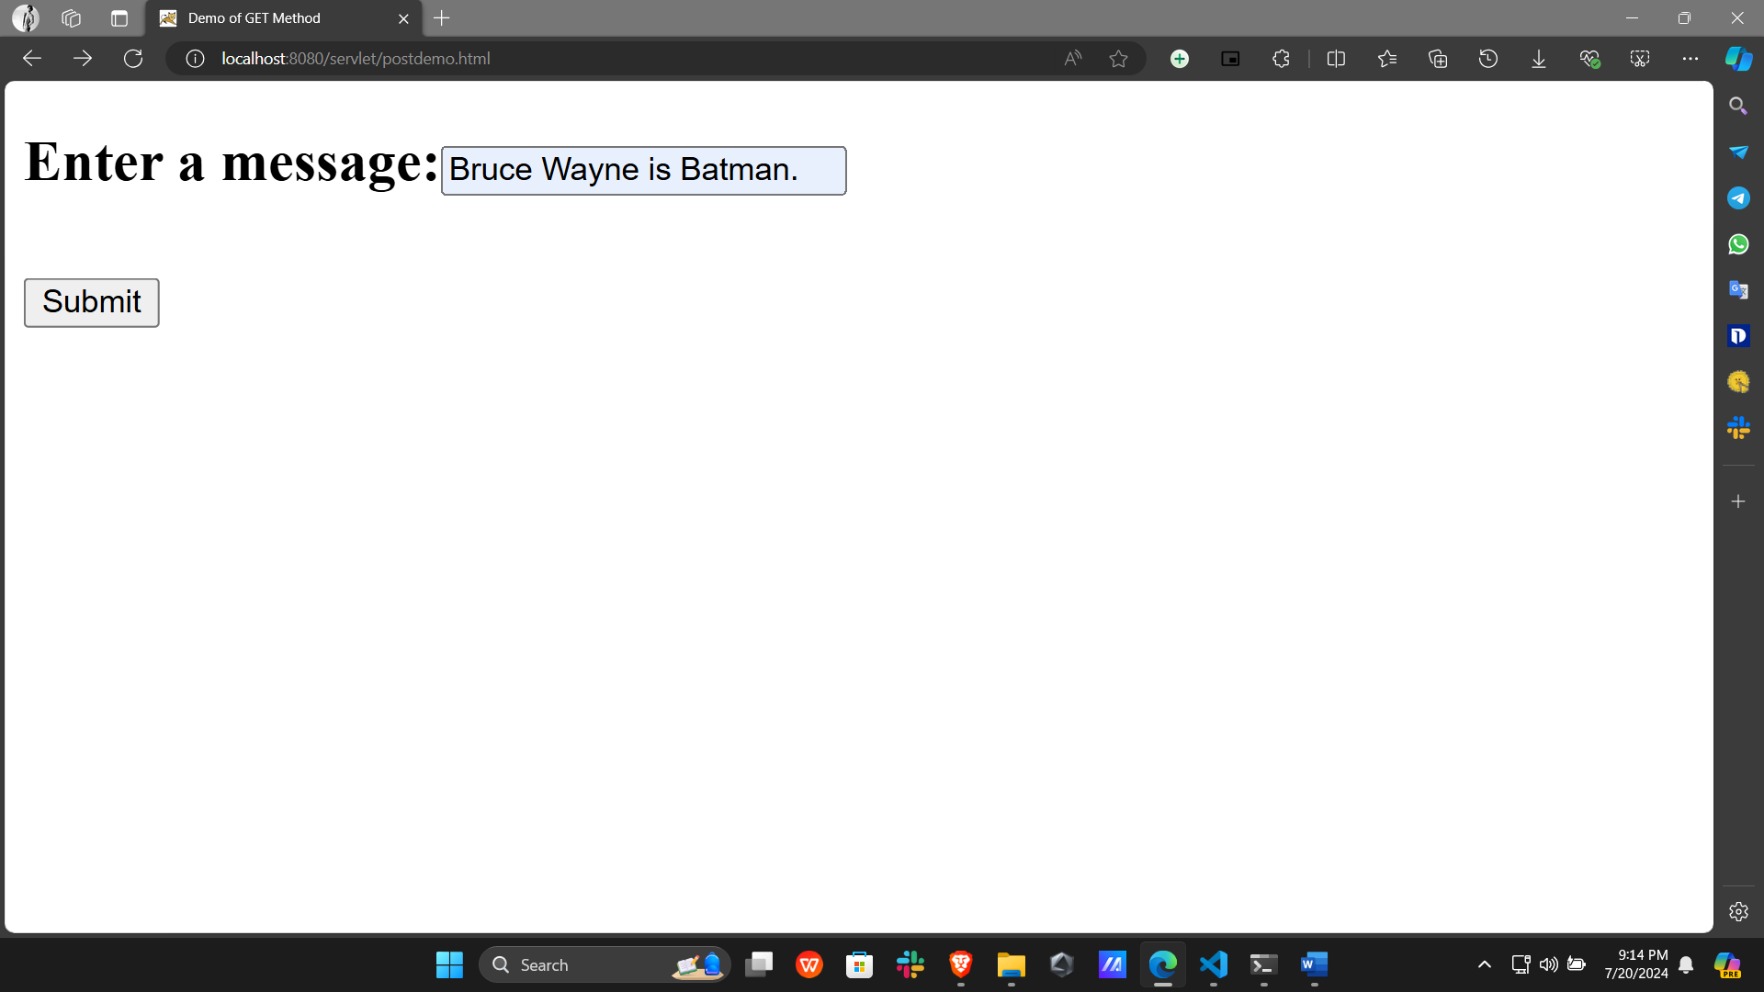

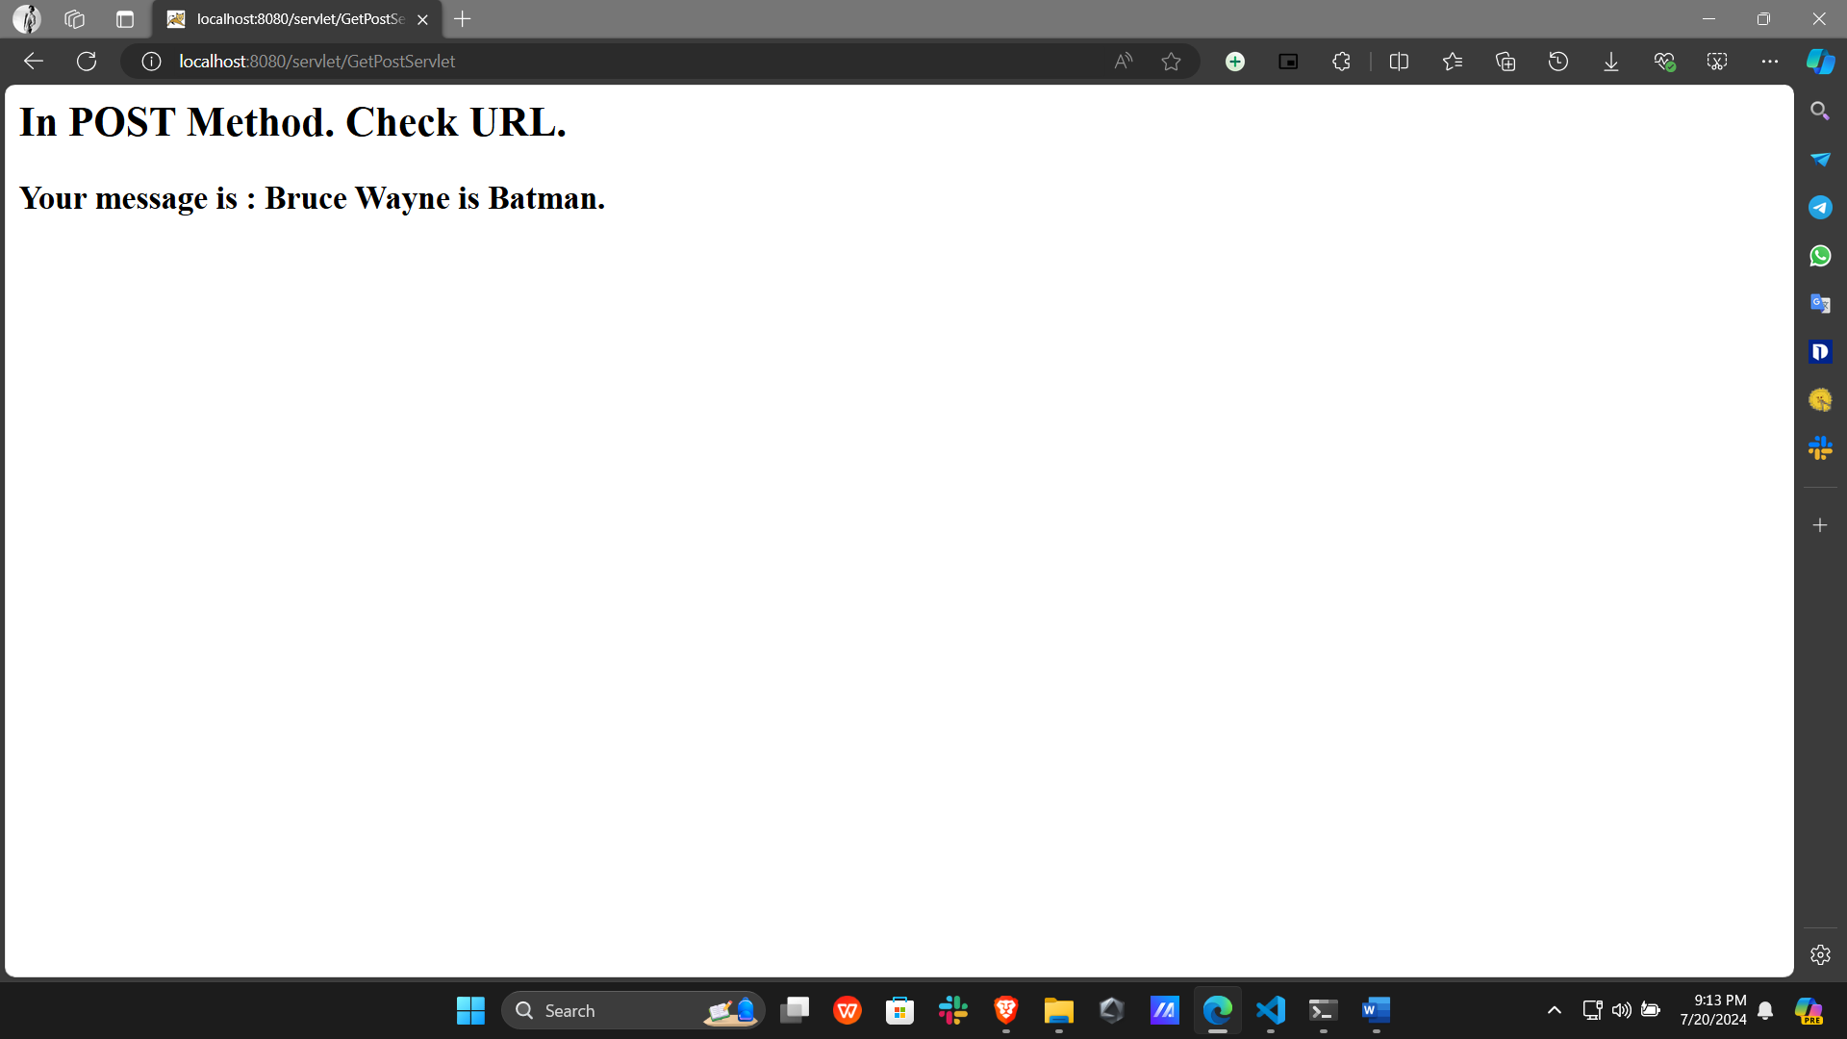

Program 12:

Write a JSP program to demonstrate the use of Java Beans.

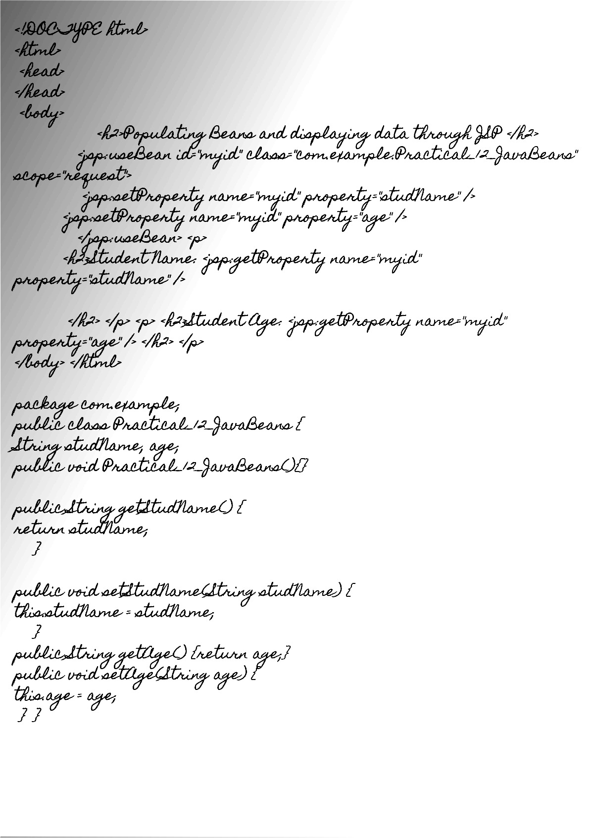

Output: